**DEVOPS LABORATORY**

**Name:** Dhilip Kumar M **Date:** 23.05.2024

**Roll Number:** 7176 21 05 015 **Experiment No.:** 05

**WORKING WITH JENKINS SERVER**

**----------------------( MAVEN JAVA PROJECT - PHASE I ) ----------------------**

**Step 1:** Open Eclipse -> File -> New -> Maven Project

* Select the maven archetype as ‘maven-archetype-quickstart’.
* Fill the details such as GroupId and ArtifactId, and enter finish to create a ‘Hello World’ .java program
* If needed, change the contents of print statement.

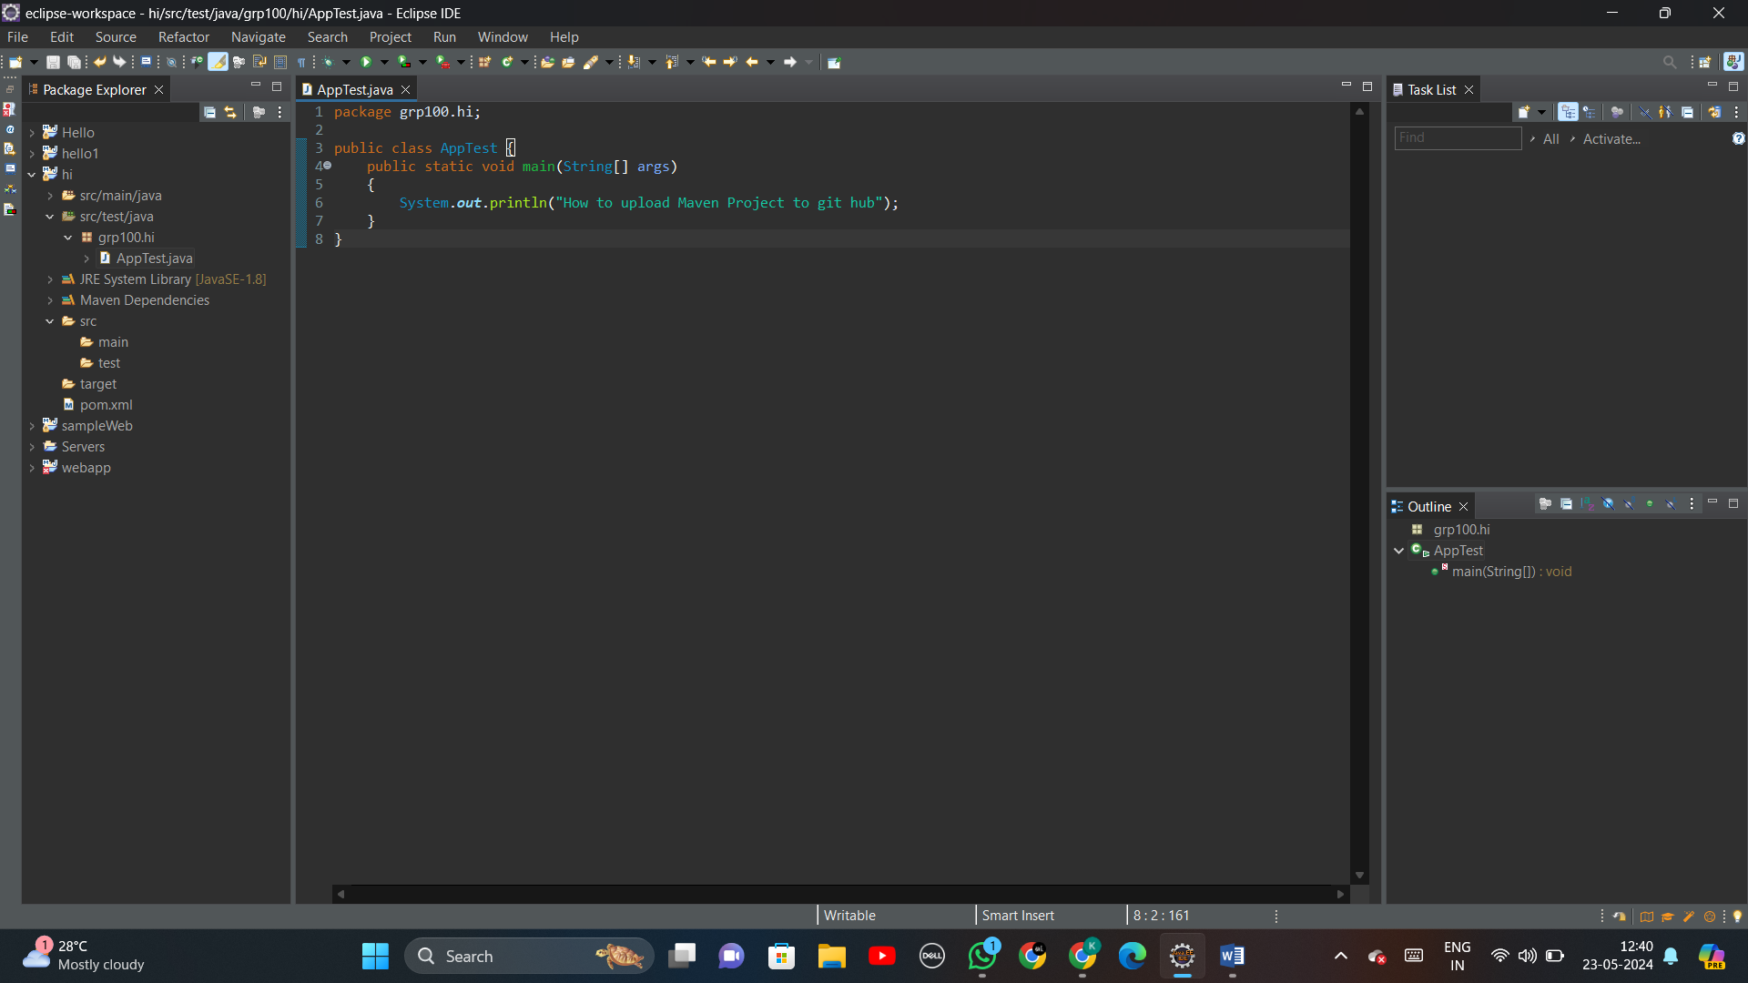

**Step 2:** Open GitHub -> Repositories -> New

* Fill the name of the repository
* Tick the README file

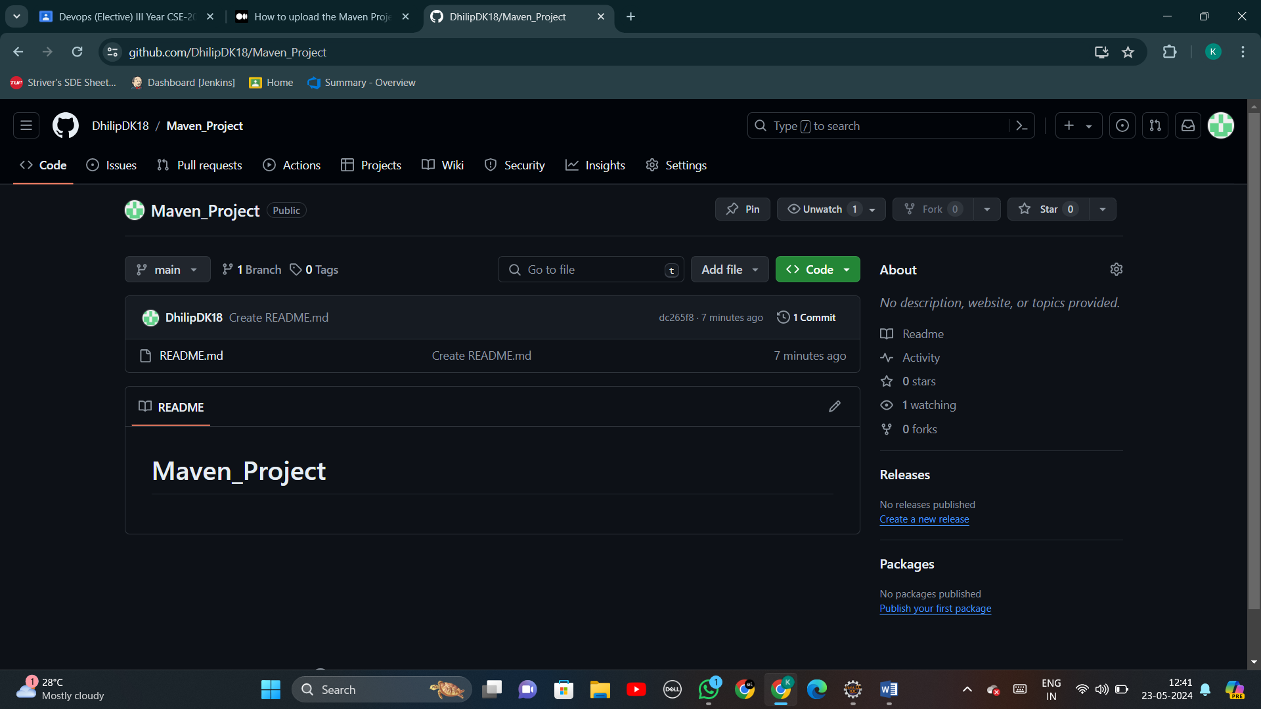

**Step 3:**

Settings -> Developer Settings -> Personal access tokens -> Tokens (classic) -> Generate new token

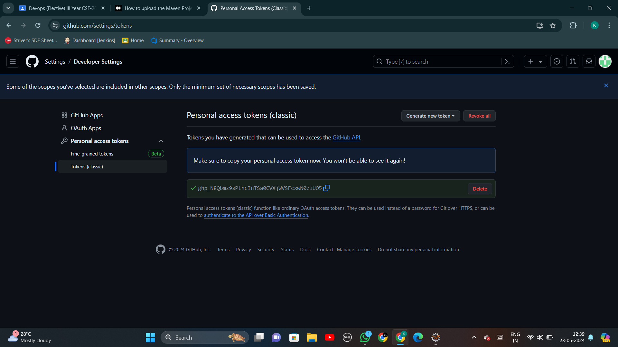

**Step 4:**

Go to GitHub Repository -> Code -> HTTPS -> Copy URL to clipboard

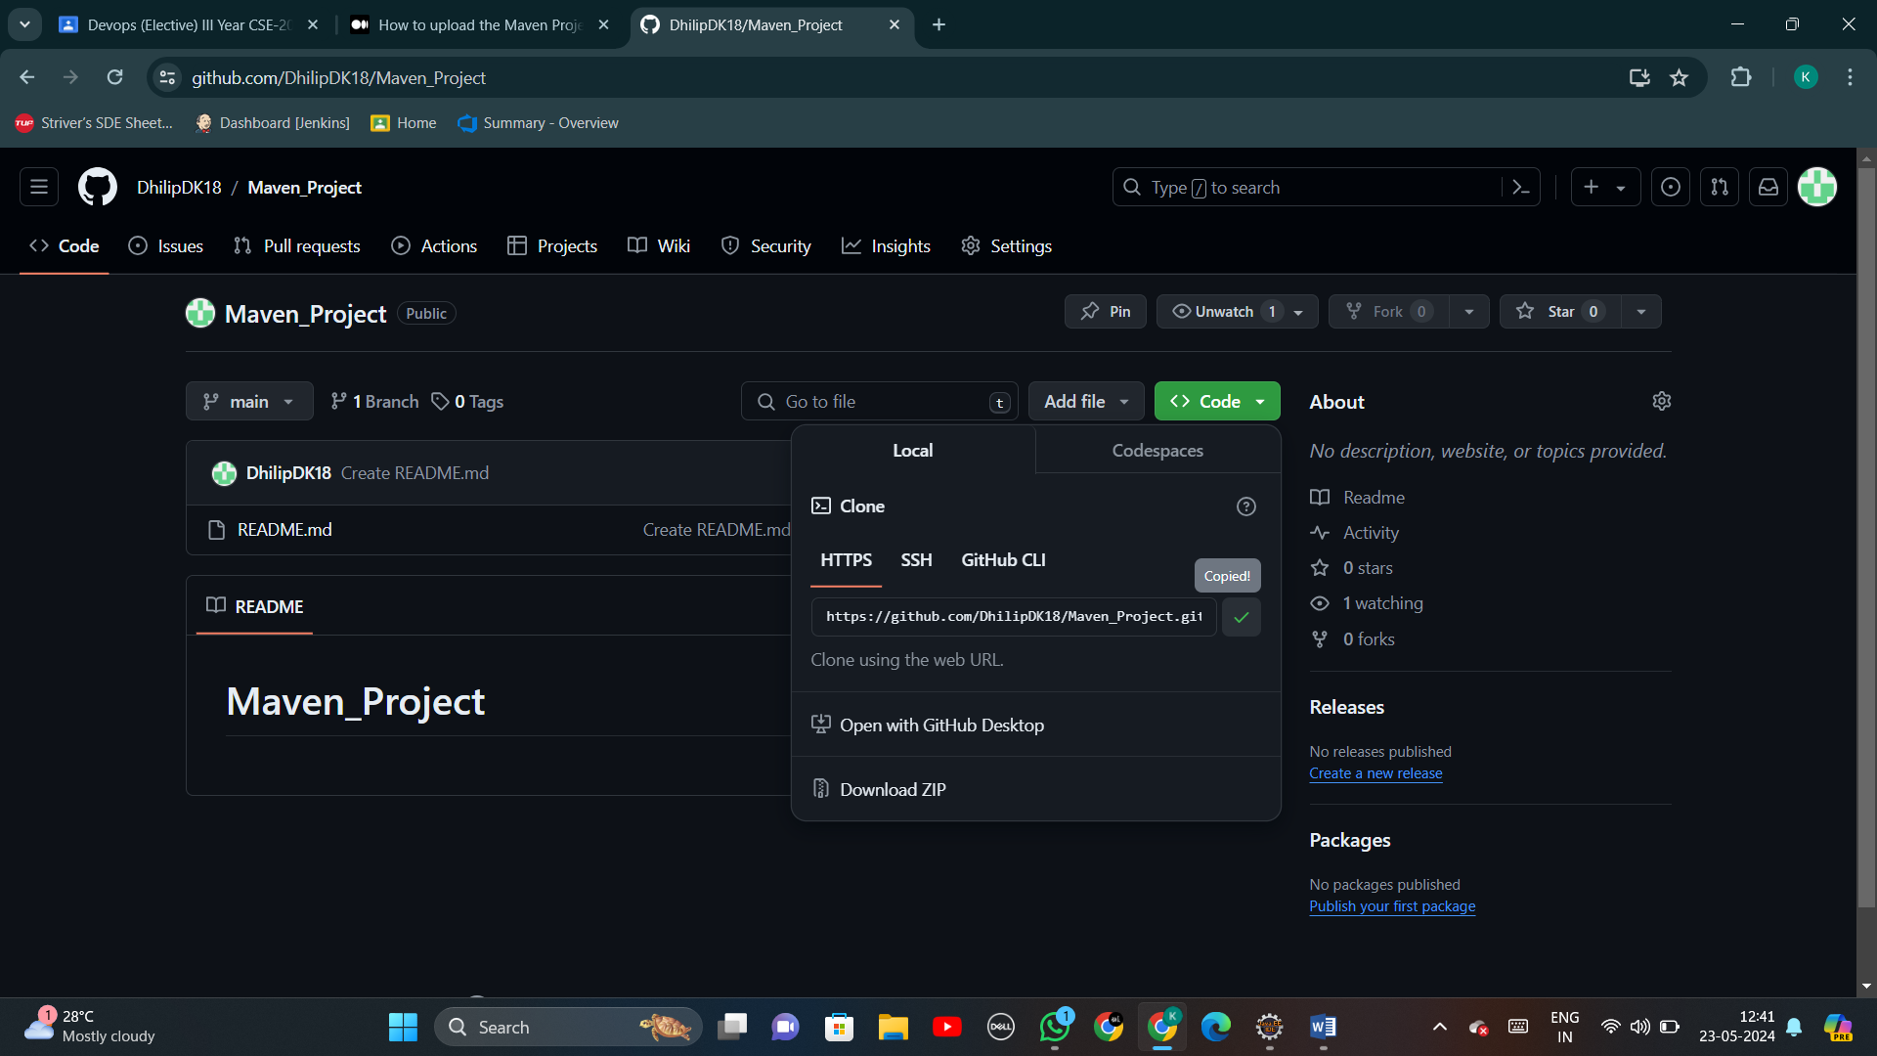

**Step 5:** Go to Eclipse (AppTest.java) -> Window -> Show view -> Others -> Git -> Git Repositories

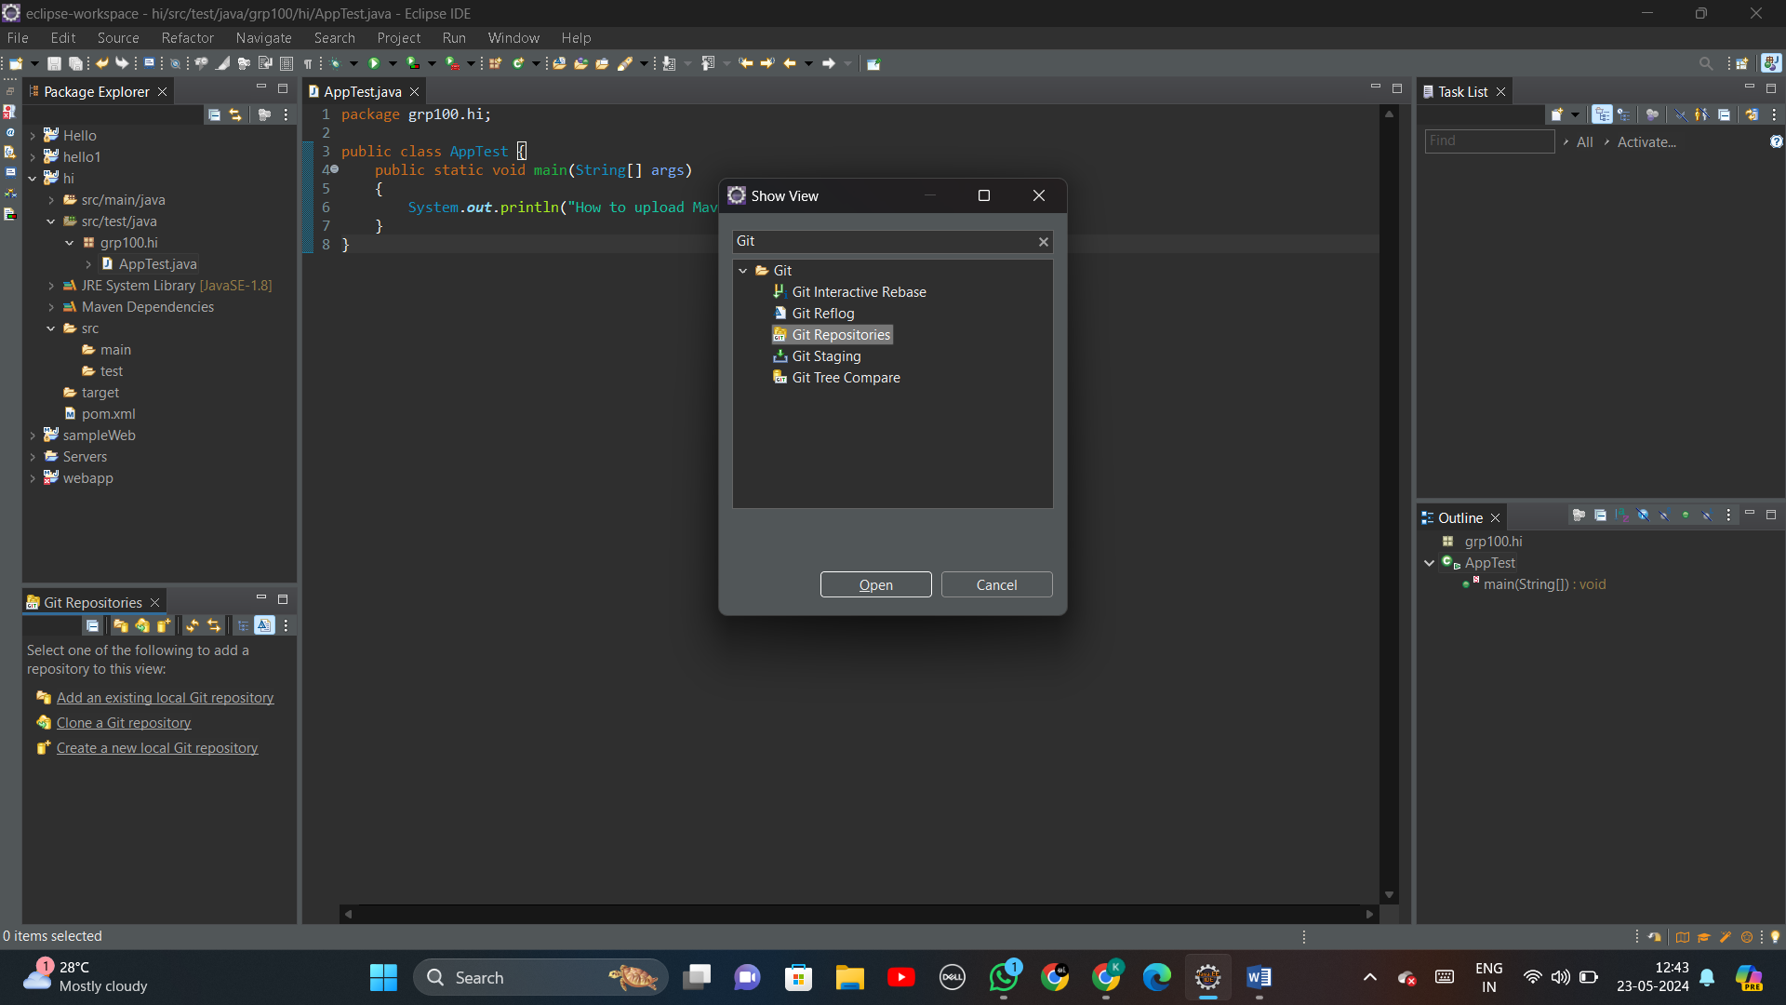

**Step 6:**

You will be directed to ‘Clone Git Repository’ section.

* Copy & Paste your Git repository URL which is copied on step (4), the Host and the repository path will be autofilled.

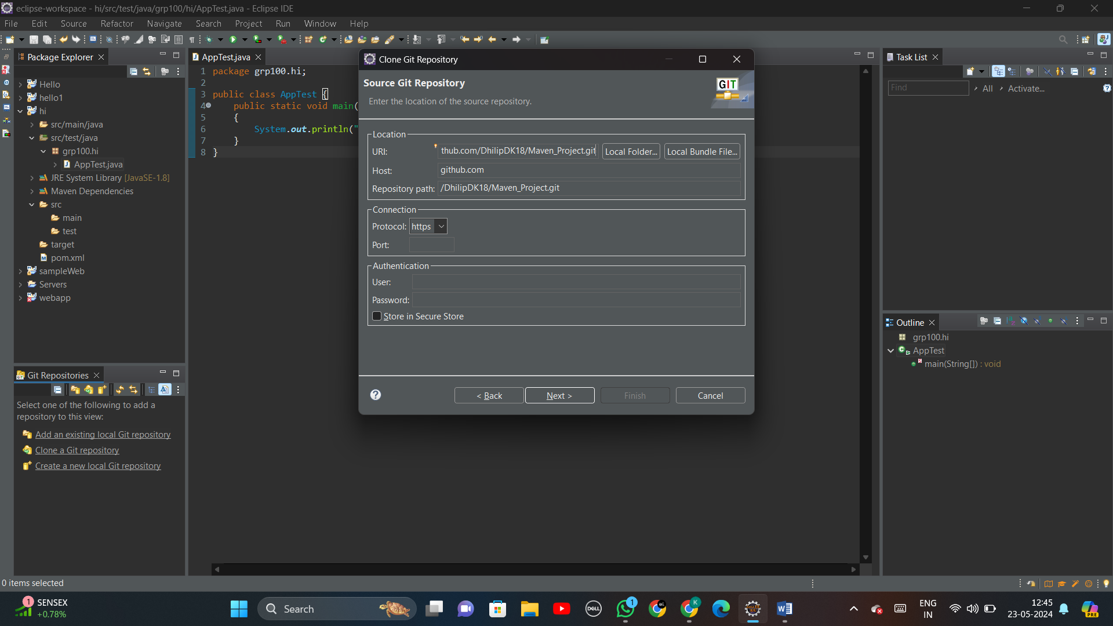

**Step 7:** After pressing ‘Next’ follow -> Next -> Finish

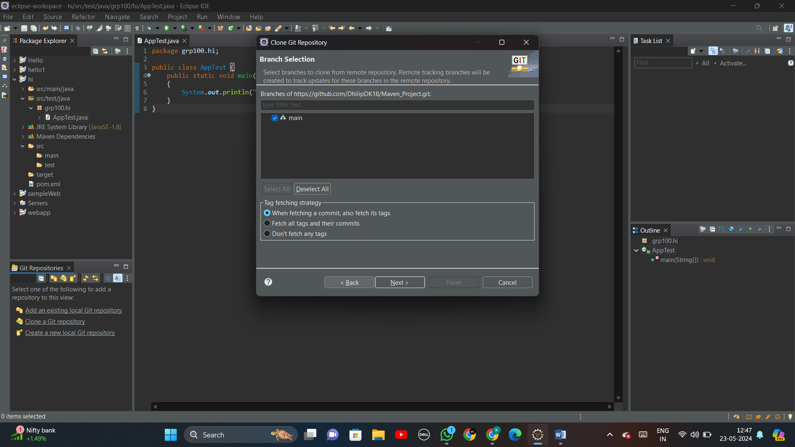

**Step 8:** Check your Directory and give ‘Finish’

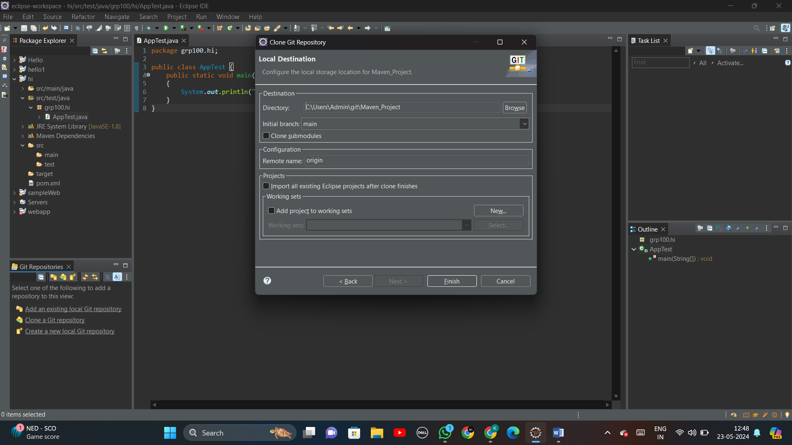

**Step 9:** Now your maven project will have a connection with the specified git repository

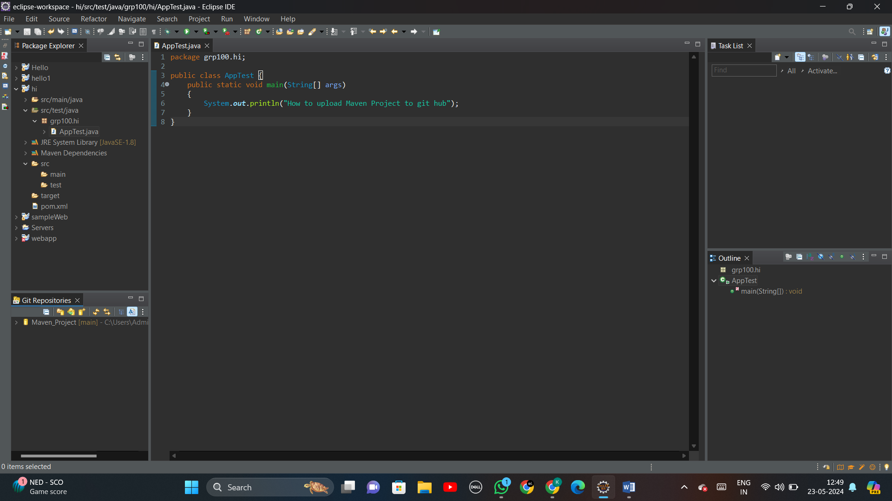

**Step 10:** Right click on the project -> Team -> Share project

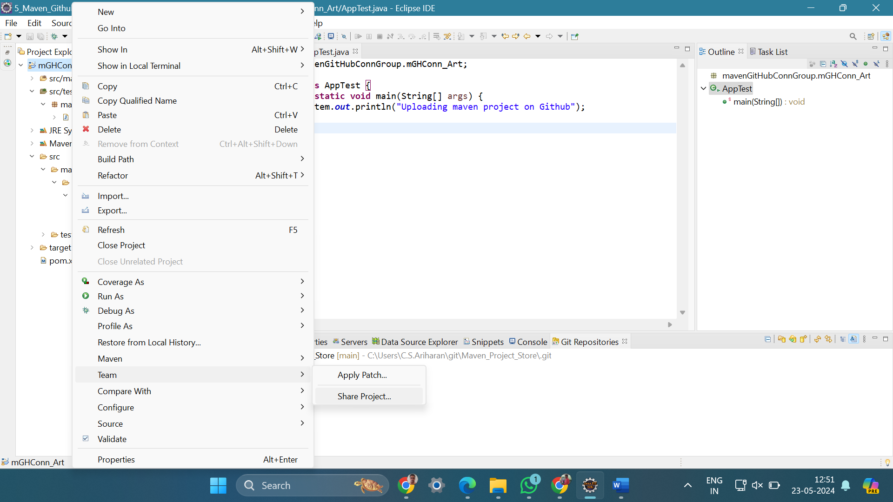

**Step 11:** In Share project, select the repository and check your working tree is properly selected.

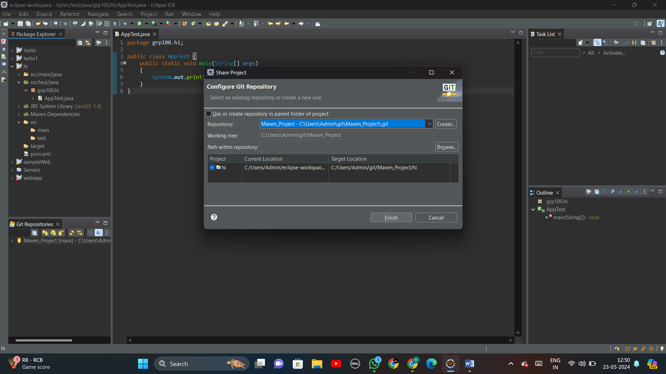

**Step 12:** Now, you can notice that the maven project is linked with the branch ‘main’ of your GitHub repository. (Example format: Project_name [Repo_name Branch_name]

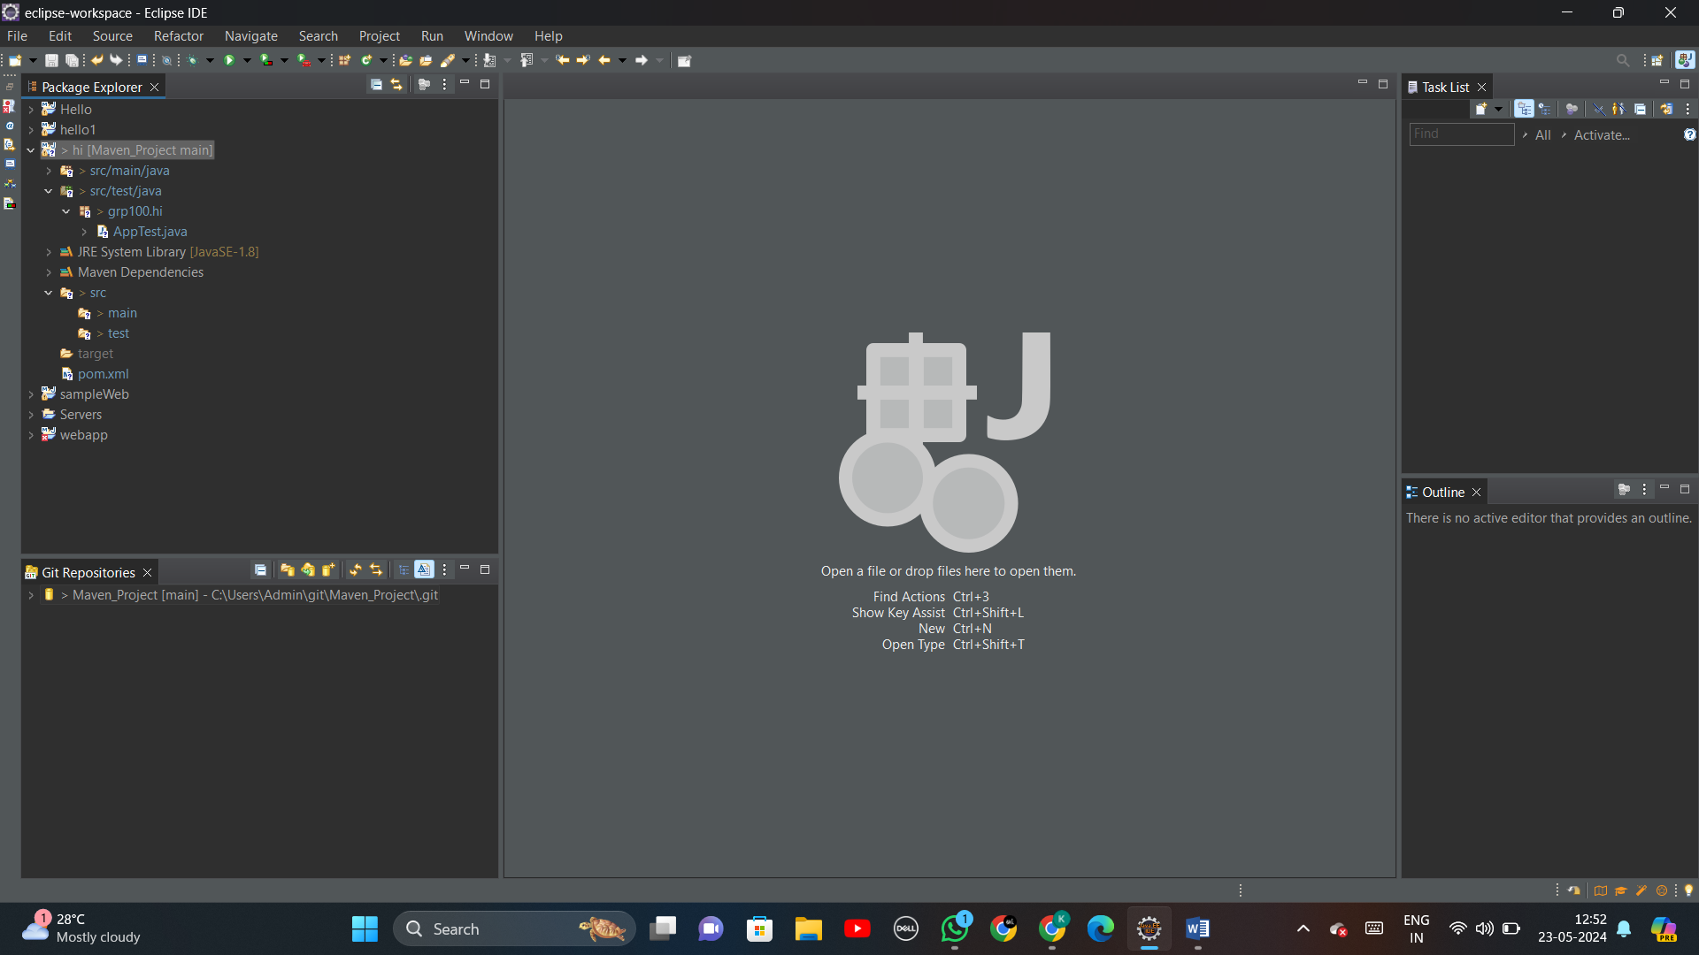

**Step 13:** Follows the steps: Window -> Show view -> Others -> Git Staging.

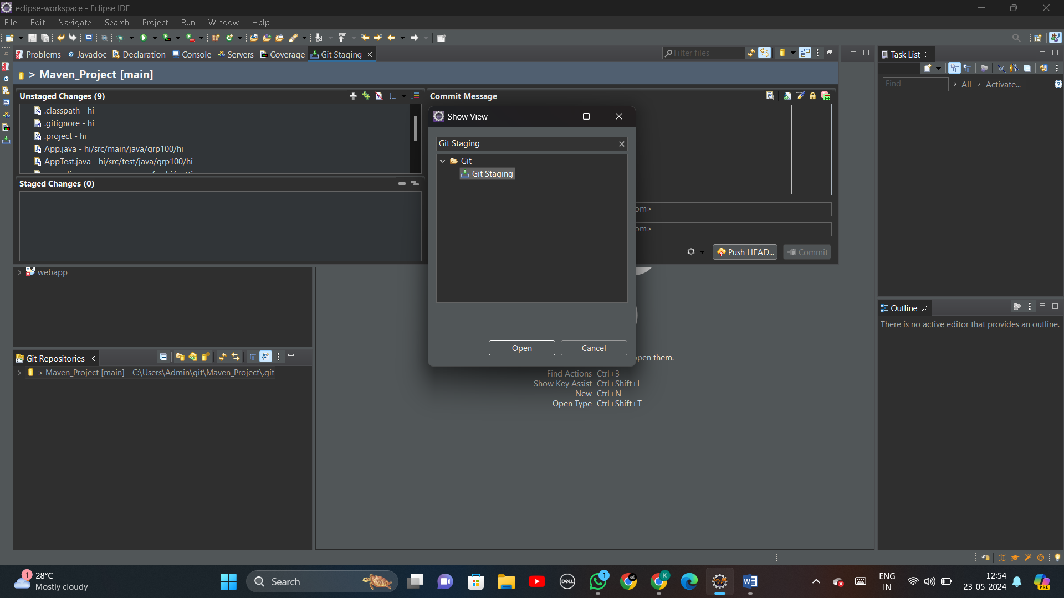

**Step 14:** Now, you can notice the maven project files are in ‘Unstaged changes’ section.

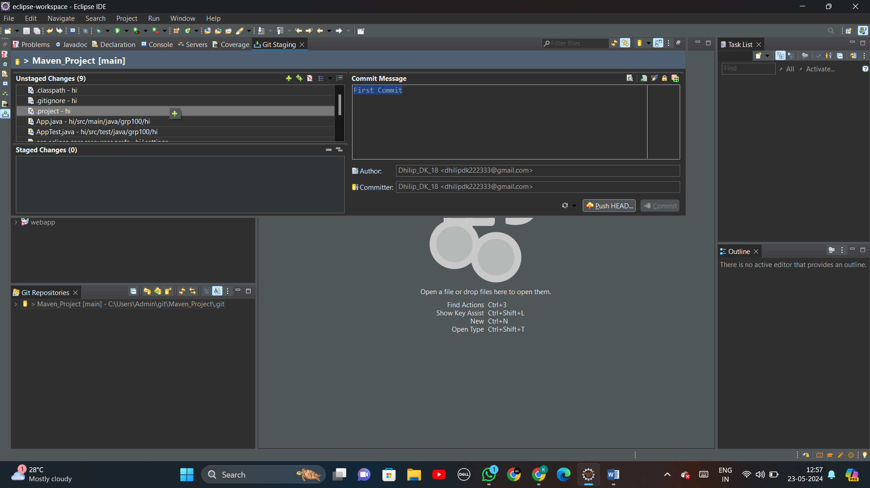

**Step 15:** Drag and drop all the maven project files from ‘Unstaged changes’ section to ‘Staged changes’ section.

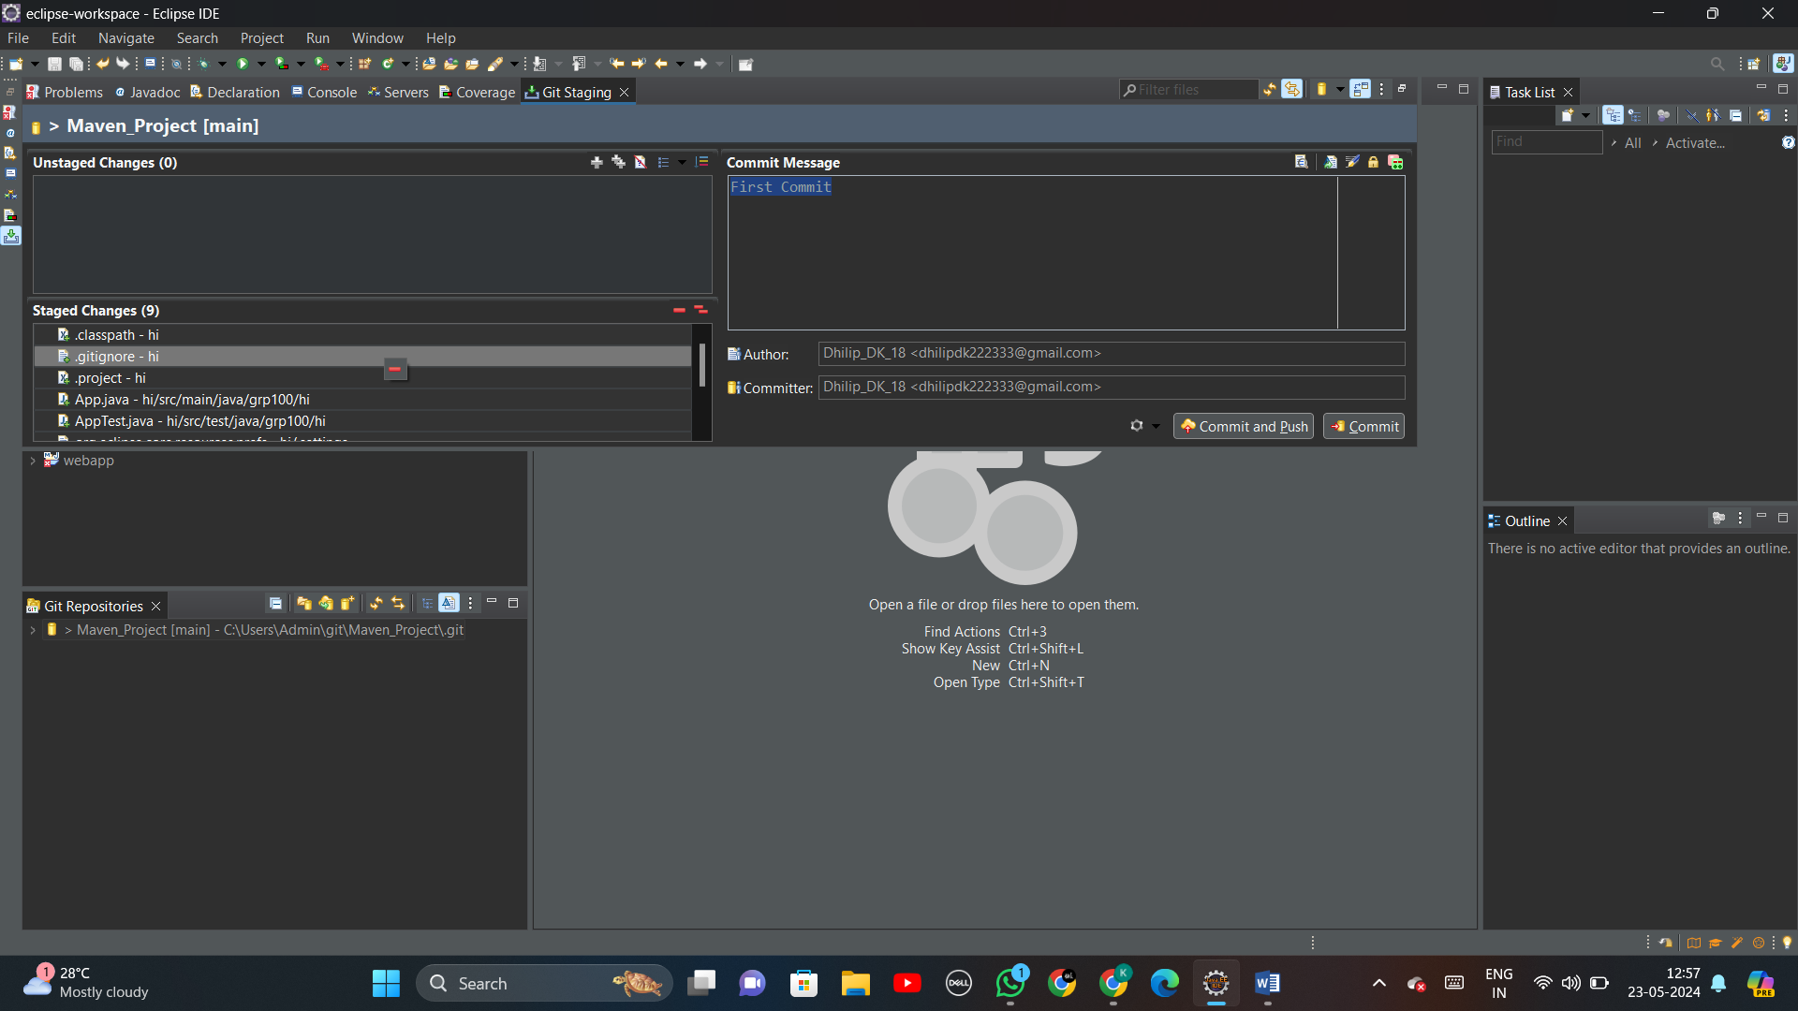

**Step 16:** Create a commit message and click ‘Commit and Push’.

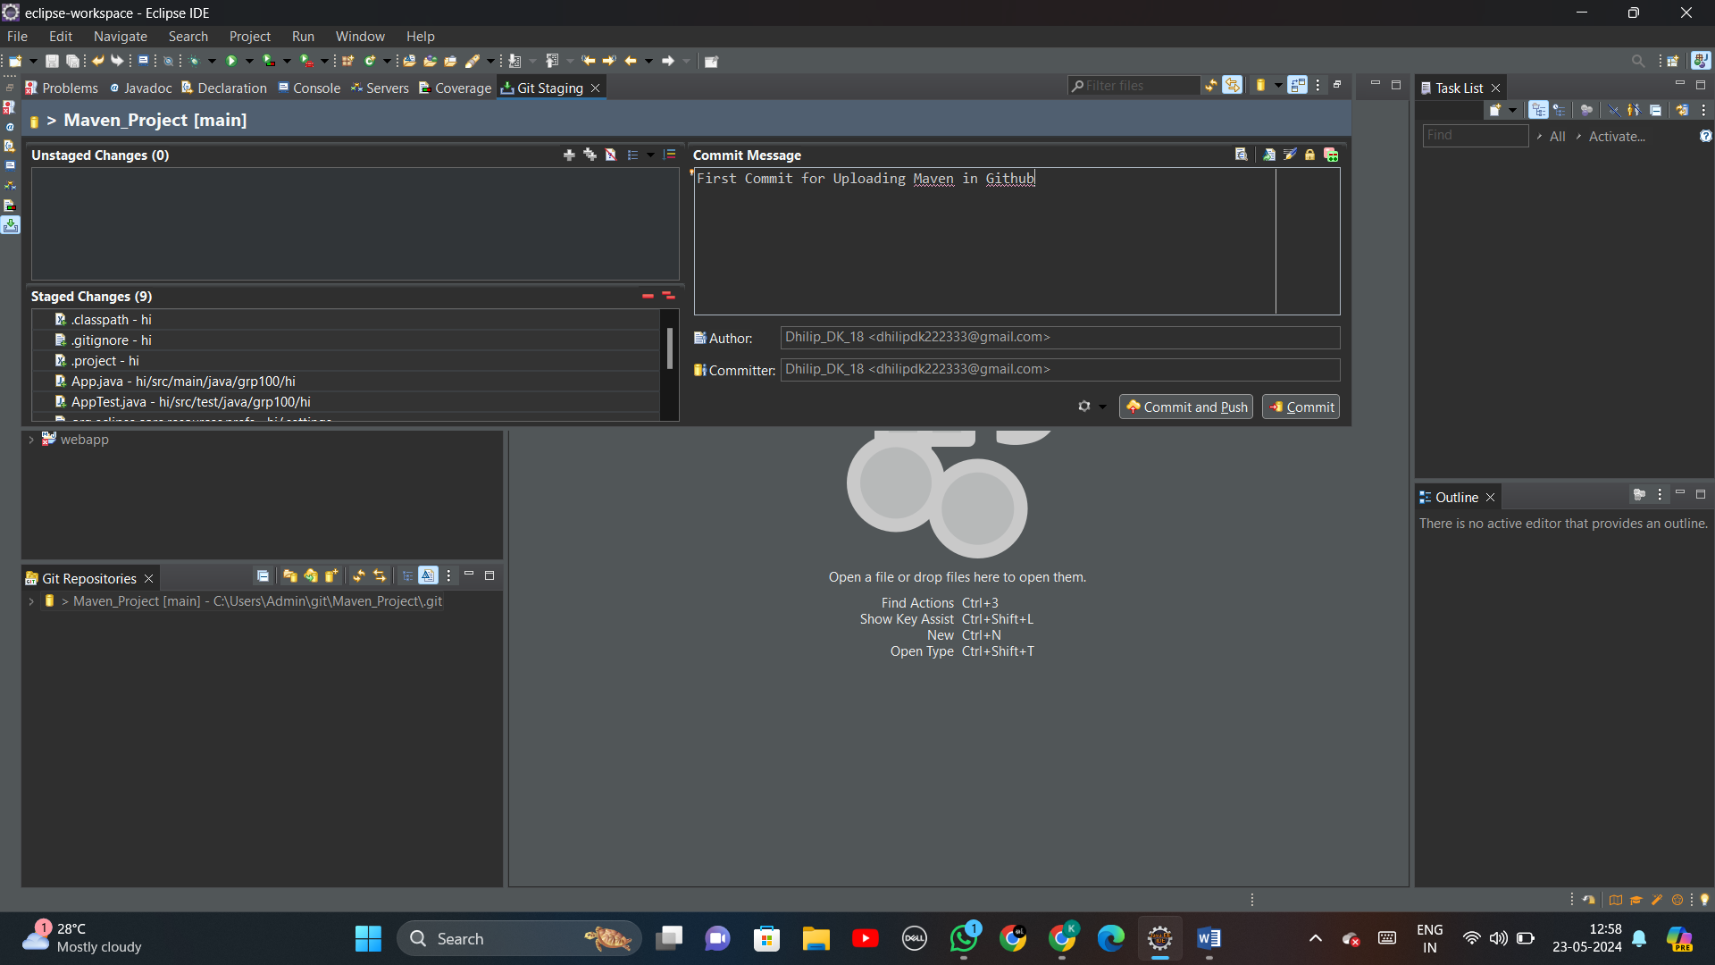

**Step 17:** You will be asked to enter User and Password.

Enter the User: With your name of the GitHub account

Enter the password: As the token generated in GitHub on Step (3)

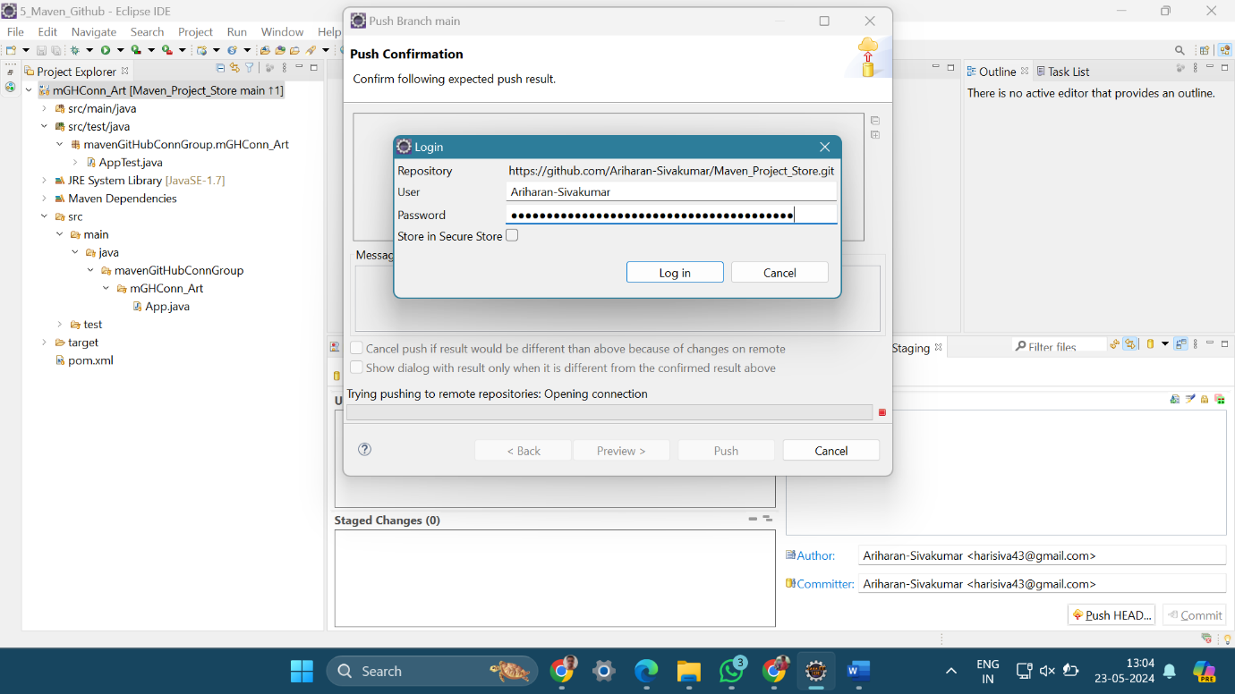

**Step 18:** Click ‘Push HEAD’ and then ‘Preview’

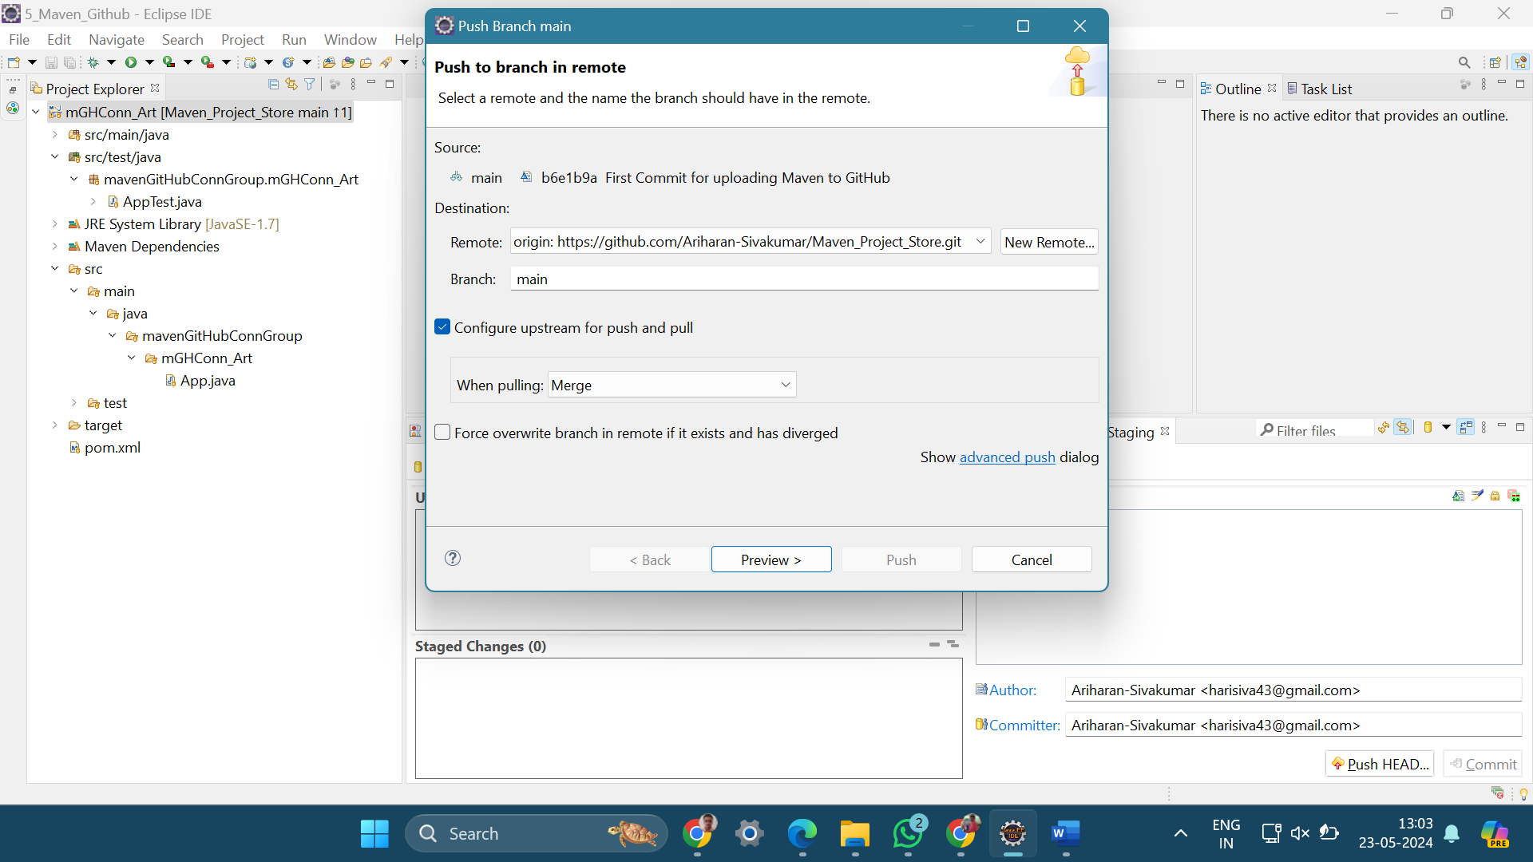

**Step 19:** Now, you can notice that the maven project files are pushed to the specified GitHub account

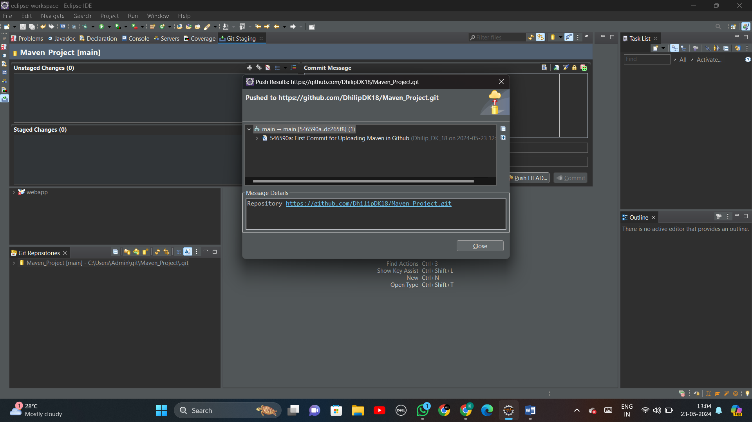

**----------------------( MAVEN JAVA PROJECT - PHASE II ) ----------------------**

**Step 20:** Check the pushed files are present in your GitHub repository

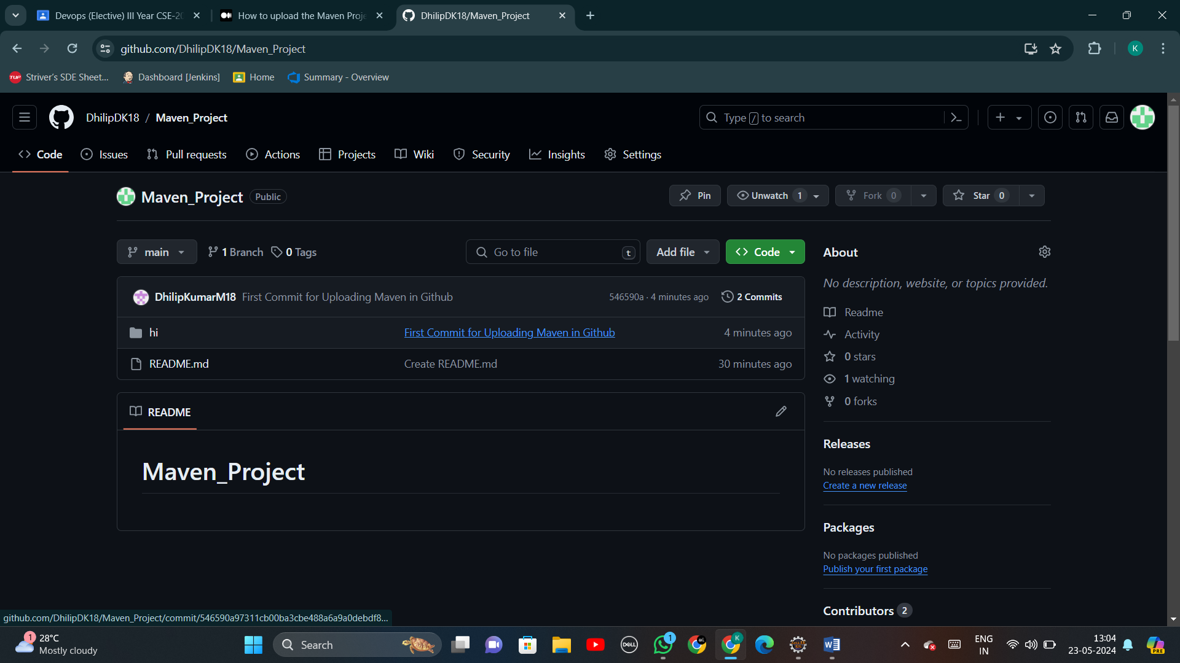

**Step 21:** Open Jenkins -> New Item -> Enter the name of the item -> Select Pipeline

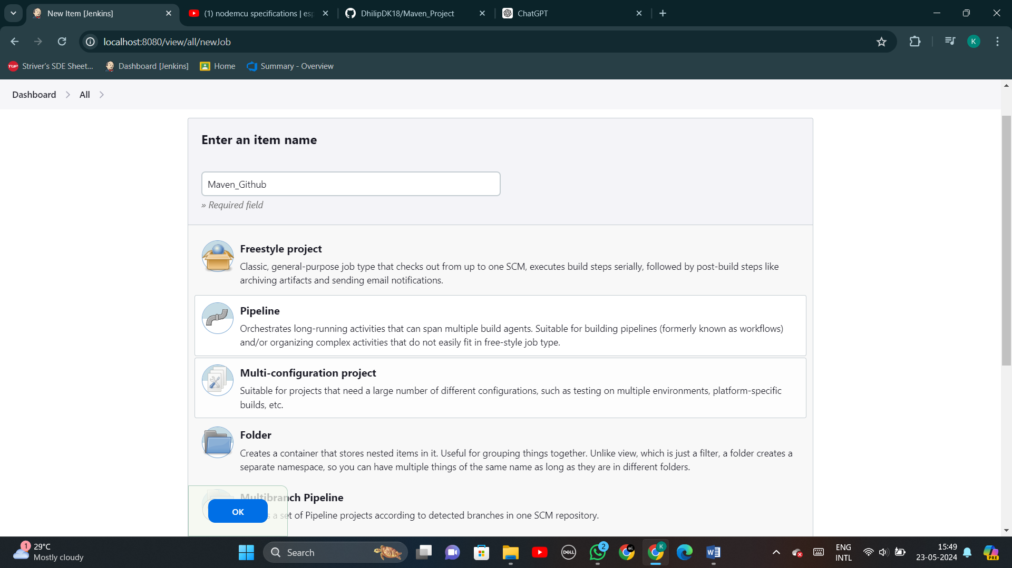

**Step 22:** Follow Pipeline -> Paste the script by modifying the git URL with your Git Repository

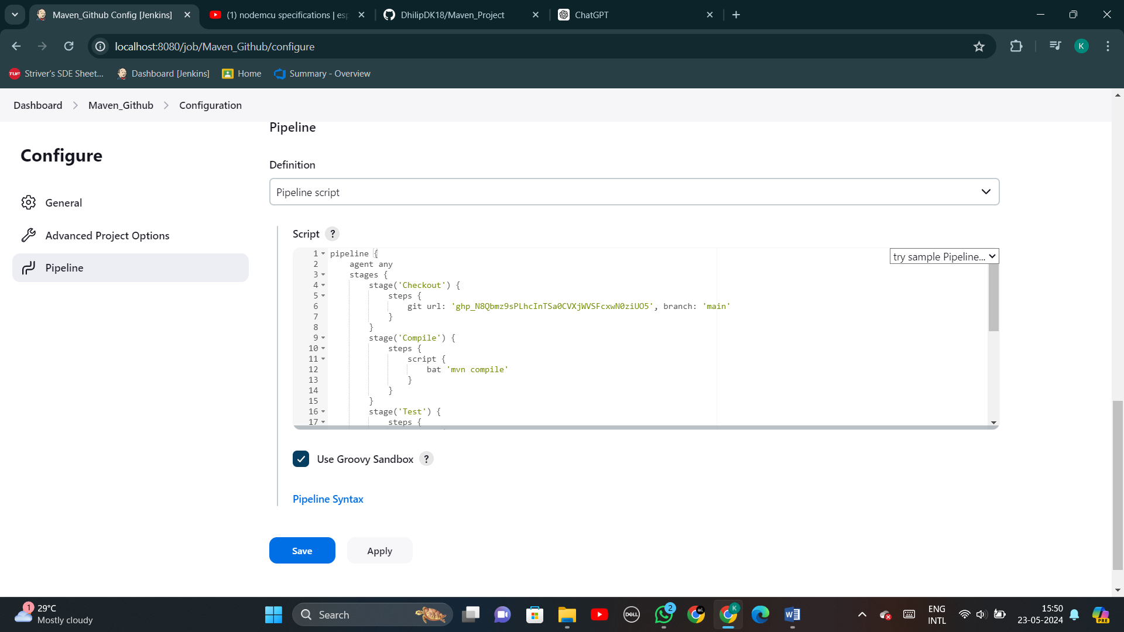

**Step 23:** Now you can view the windows for the newly created pipeline

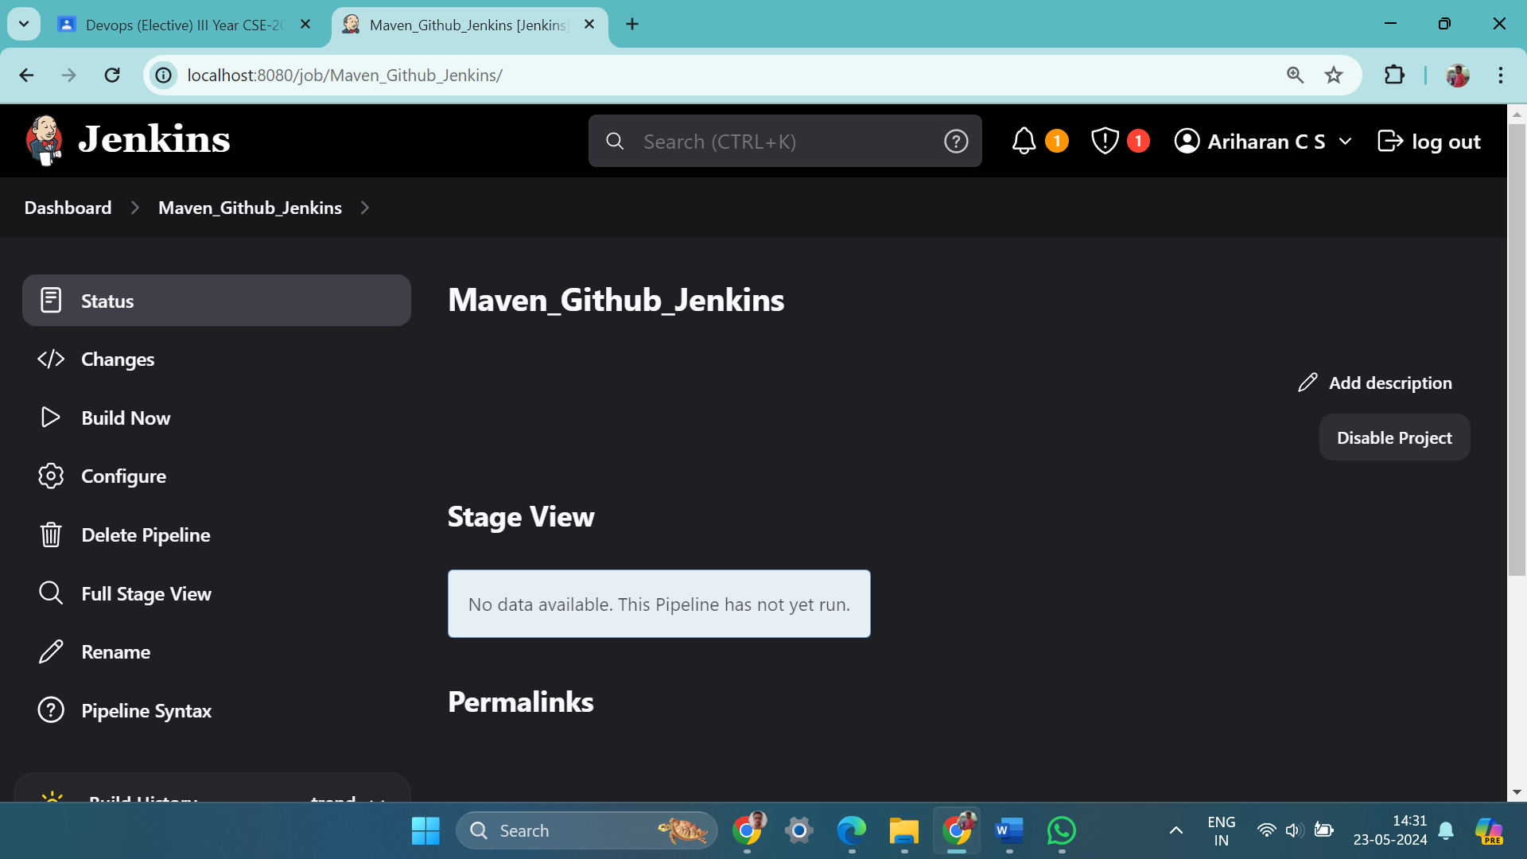

**Step 24:** Build the project by clicking ‘Build Now’.

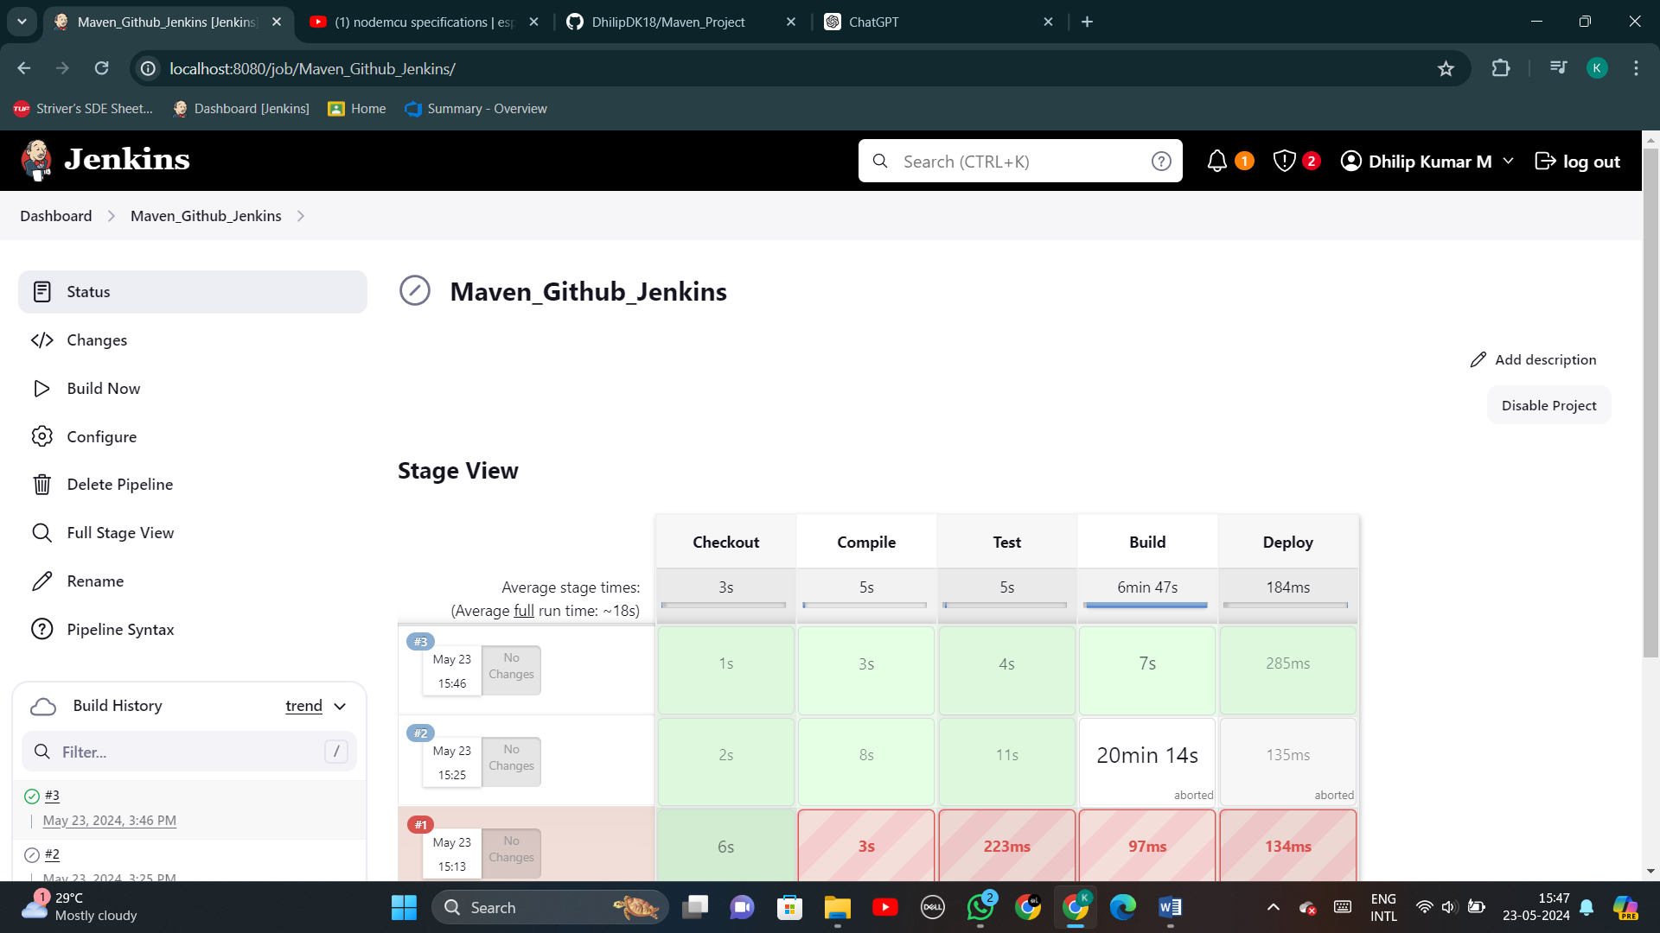

**Step 25:** Now, you can verify that target folder has been created with a .jar file

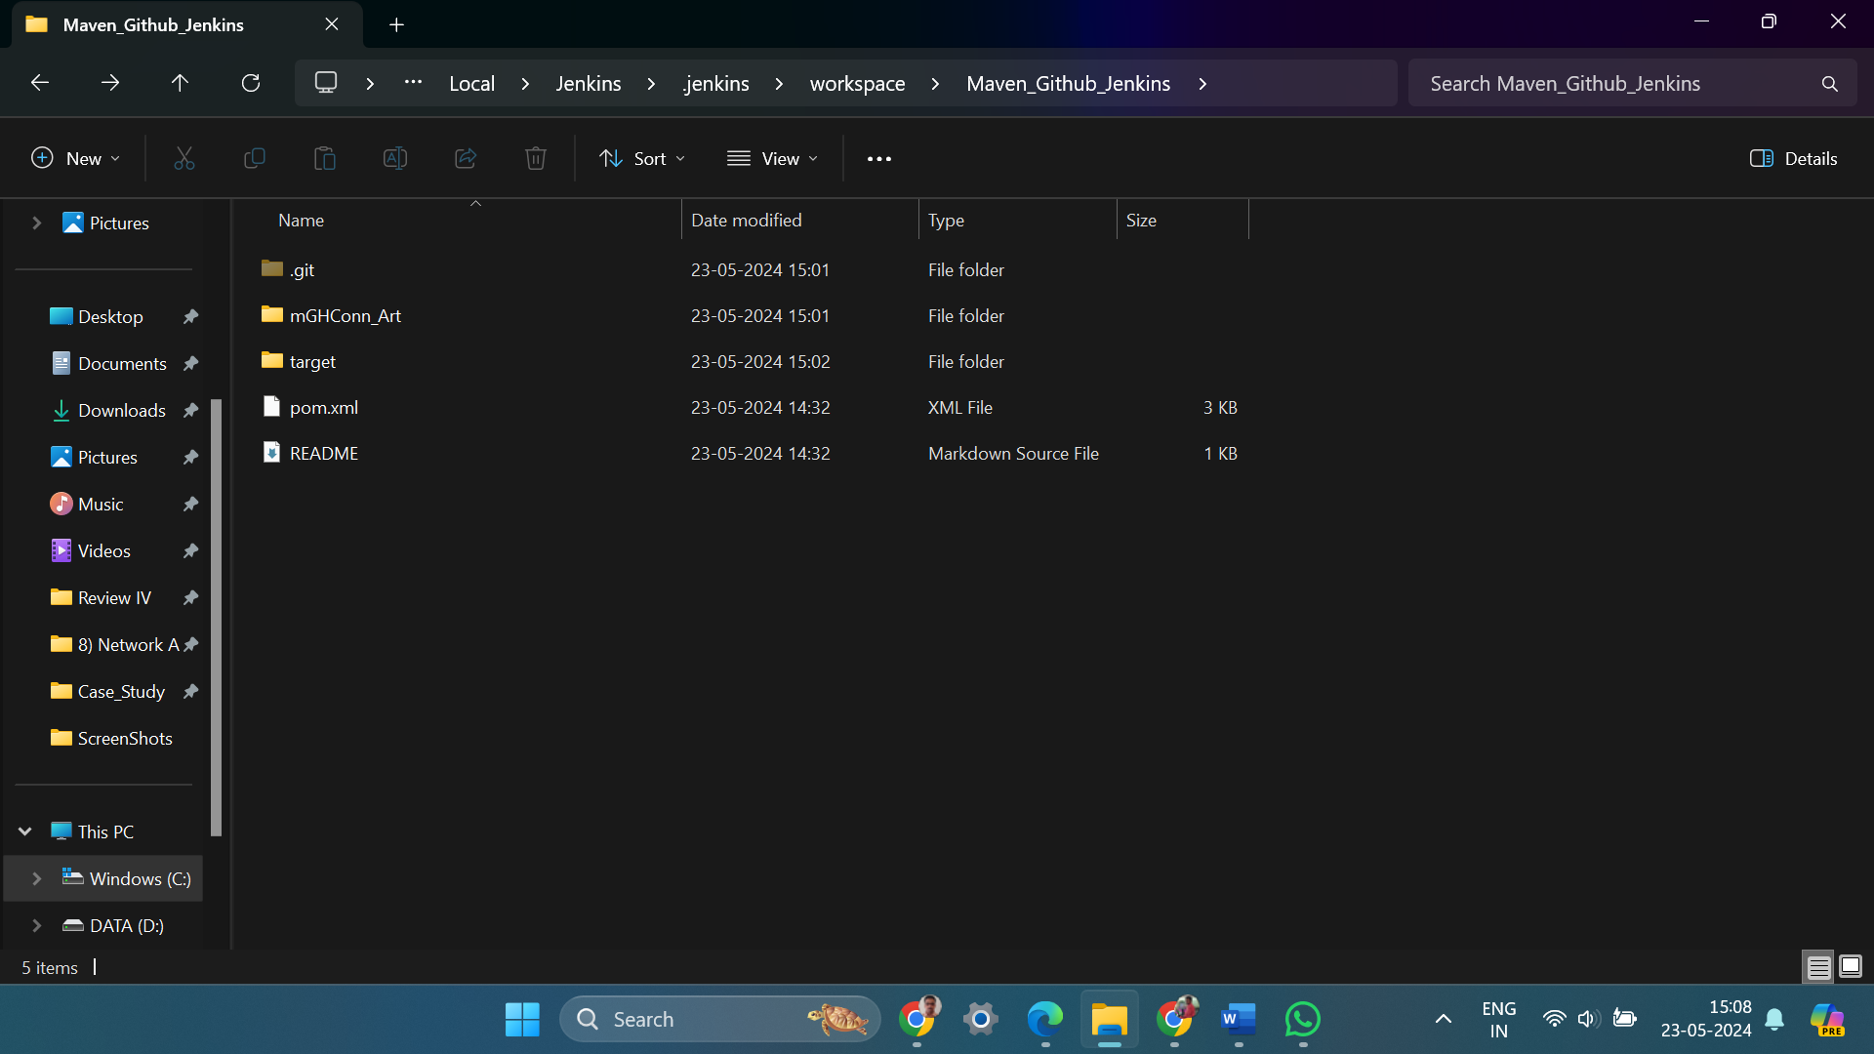

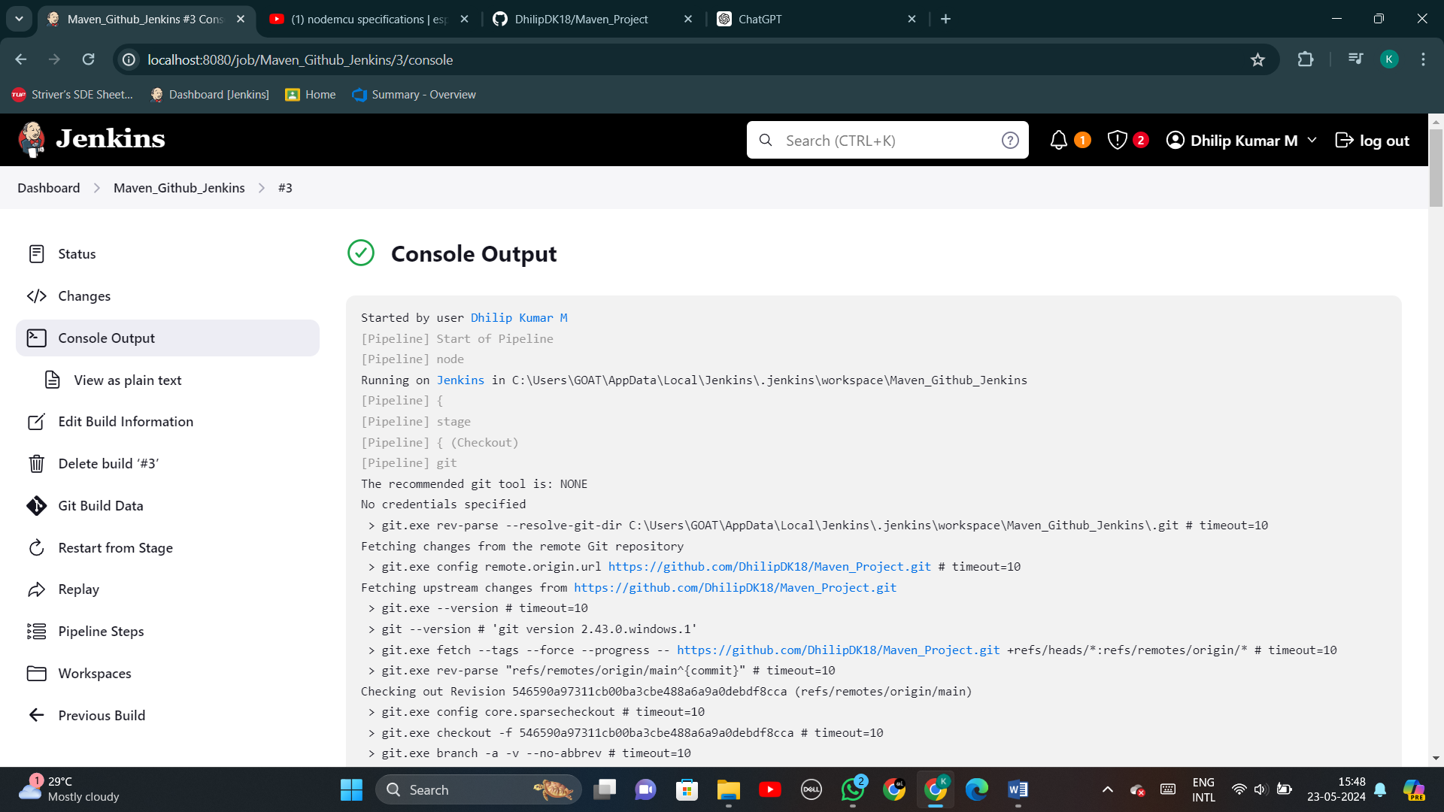

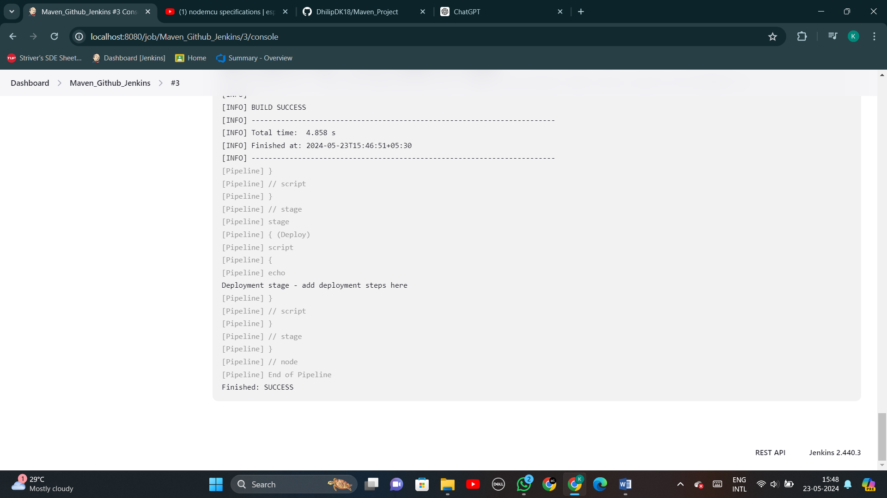

**----------------------( MAVEN WEB PROJECT - PHASE I ) ----------------------**

**Step 1:** Open Eclipse -> File -> New -> Maven Project

* Select the maven archetype as ‘maven-archetype-webapp.
* Fill the details such as GroupId and ArtifactId, and enter finish to create a ‘Hello World’ web program
* If needed, change the contents of print statement.

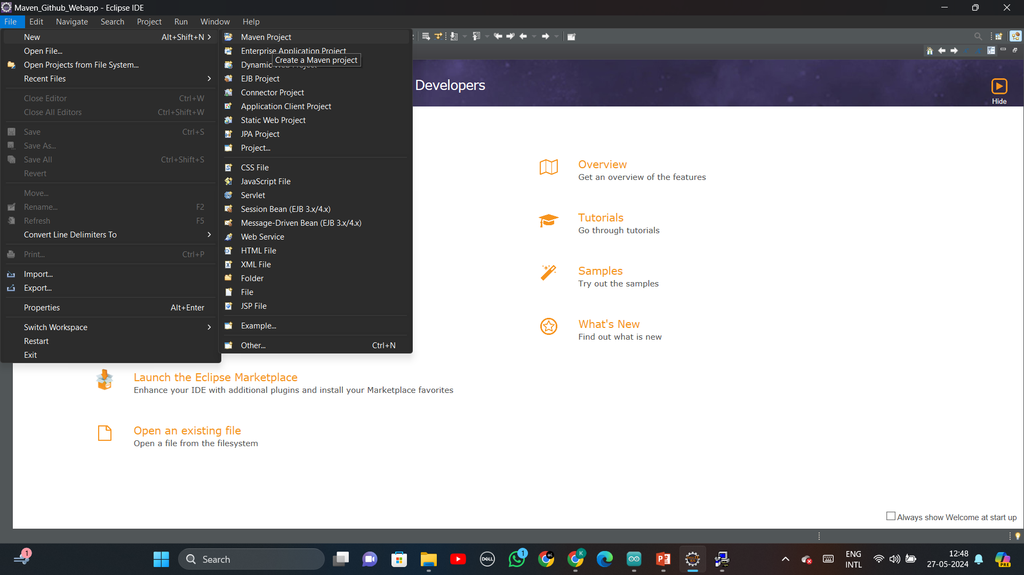

**Step 2:** Open GitHub -> Repositories -> New

* Fill the name of the repository
* Tick the README file

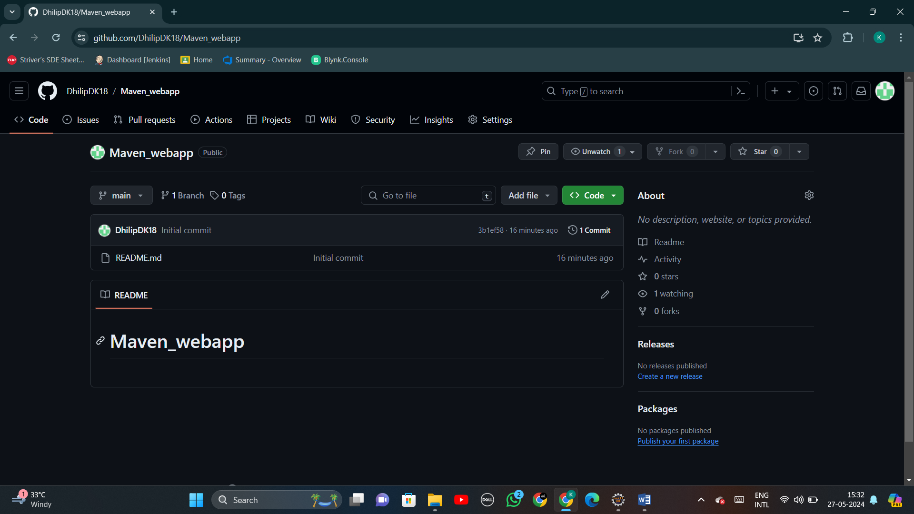

**Step 3:**

Settings -> Developer Settings -> Personal access tokens -> Tokens (classic) -> Generate new token



**Step 4:**

Go to GitHub Repository -> Code -> HTTPS -> Copy URL to clipboard

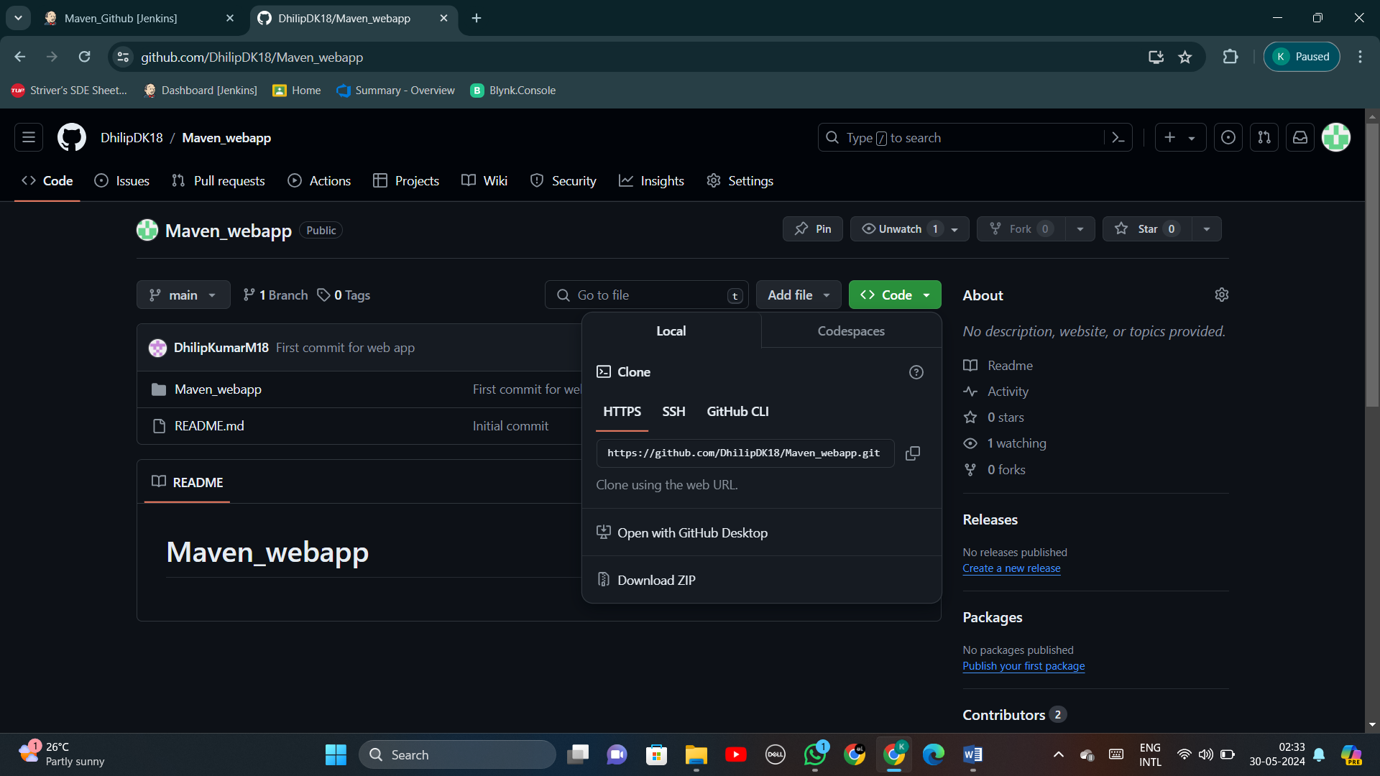

**Step 5:** Go to Eclipse -> Window -> Show view -> Others -> Git -> Git Repositories

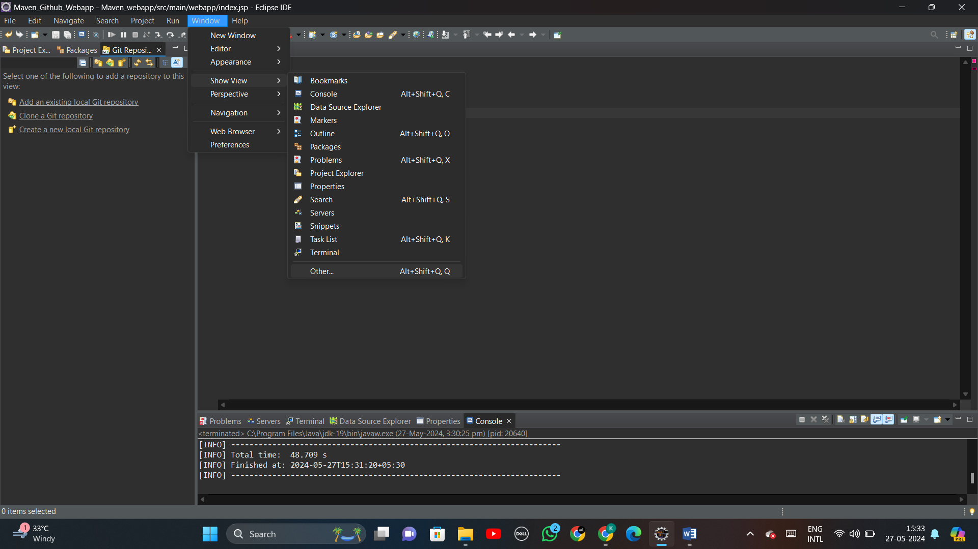

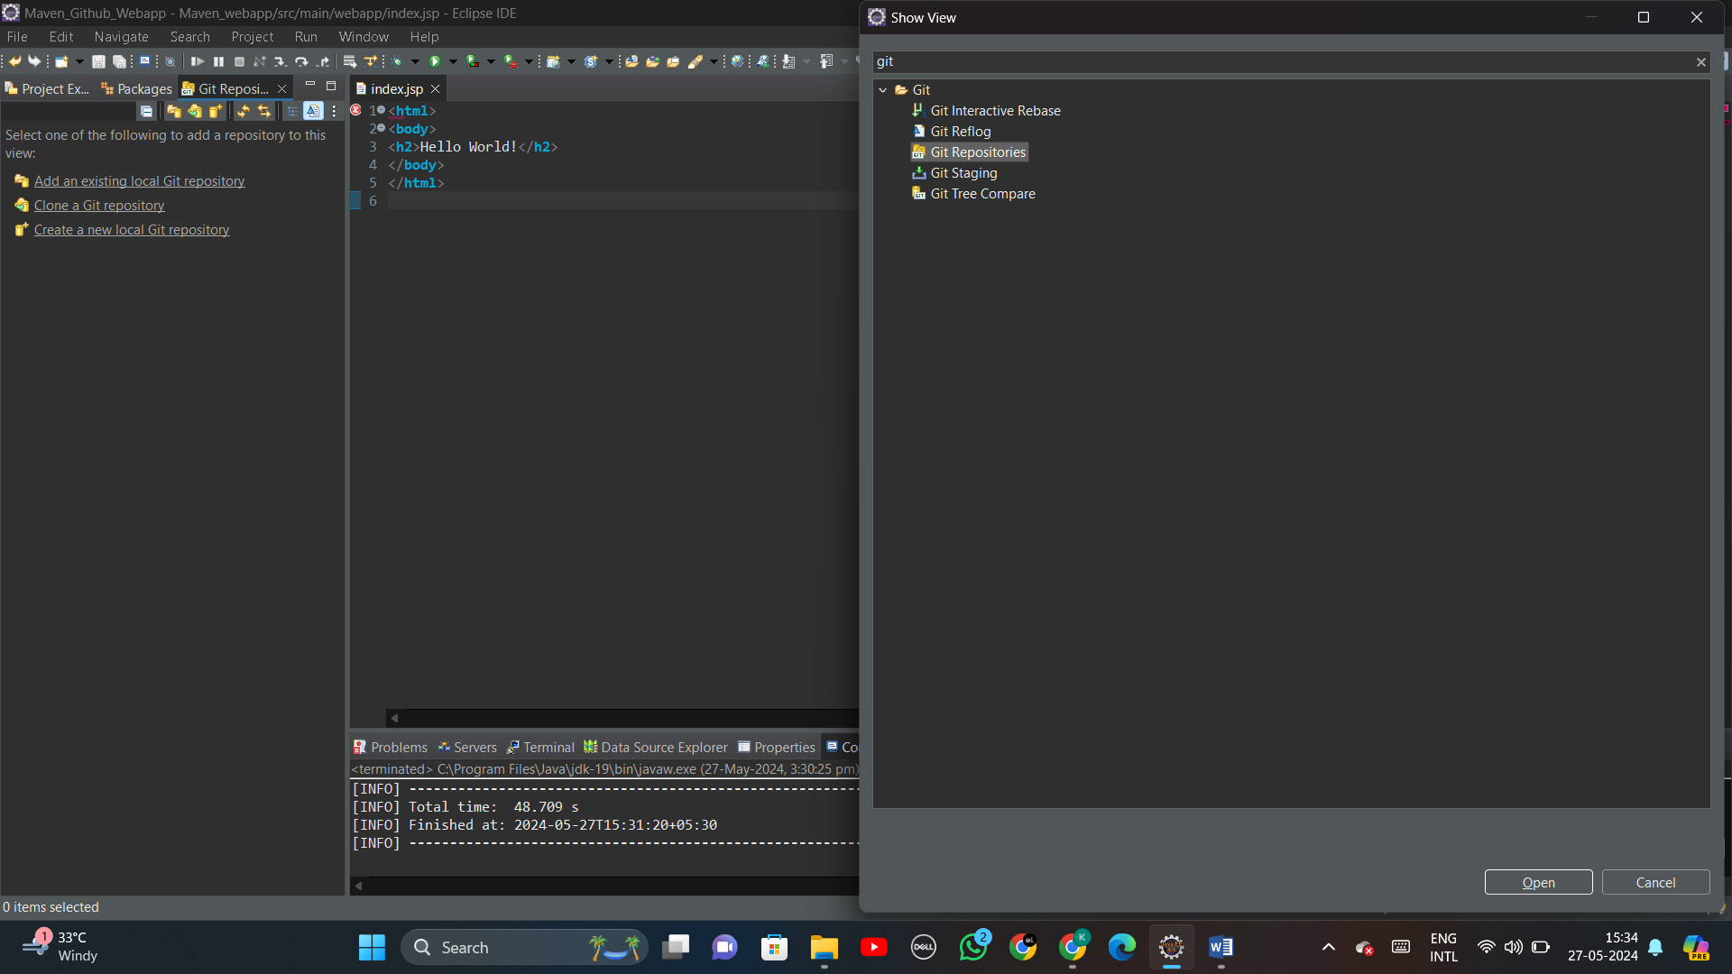

**Step 6:**

You will be directed to ‘Clone Git Repository’ (at bottom) section.

* Copy & Paste your Git repository URL which is copied on step (4), the Host and the repository path will be autofilled.

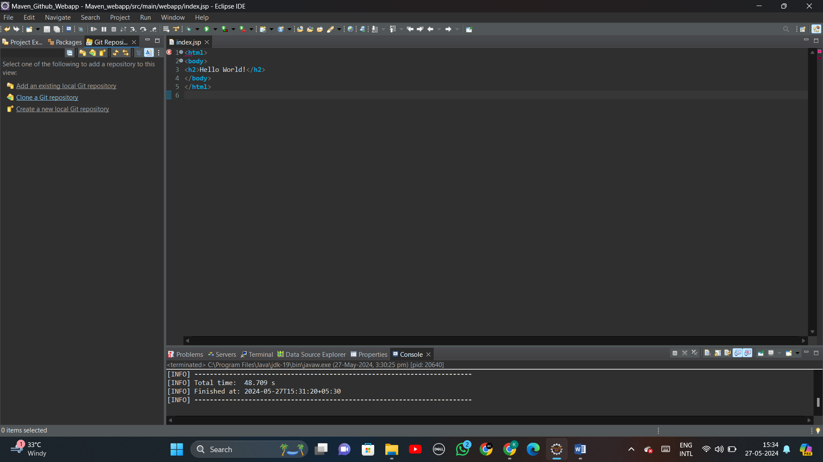

**Step 7:** After pressing ‘Next’ follow -> Next -> Finish

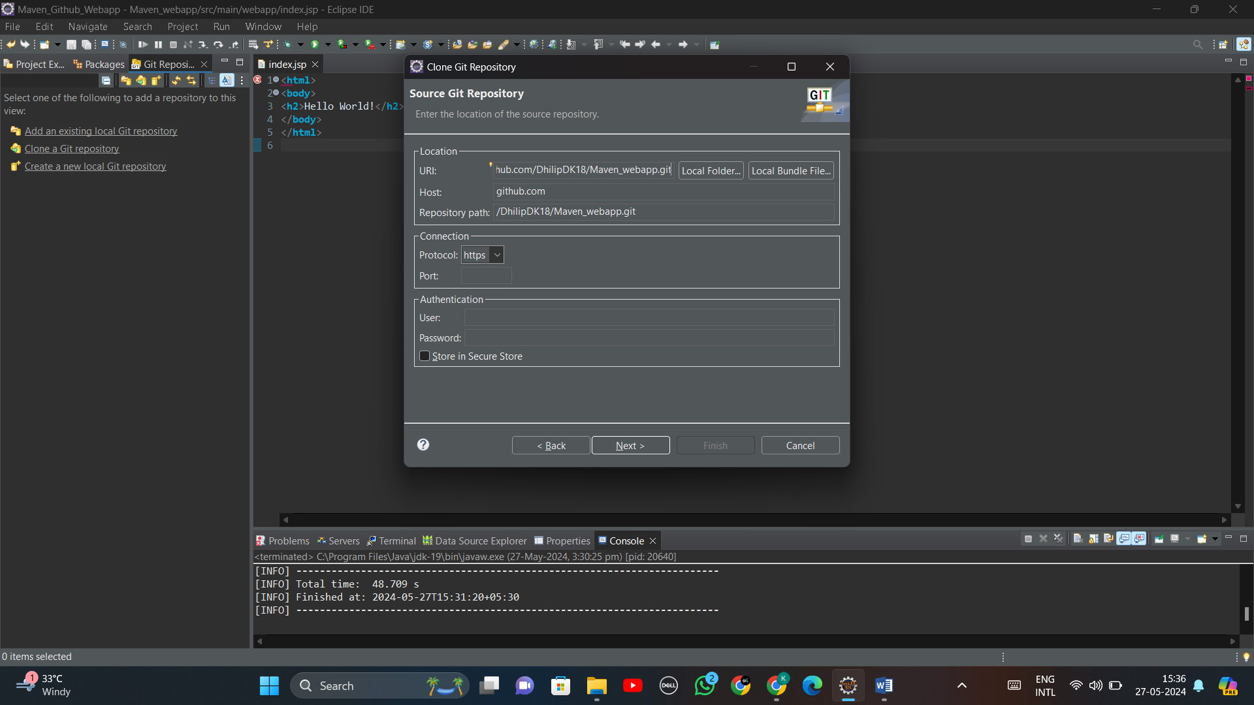

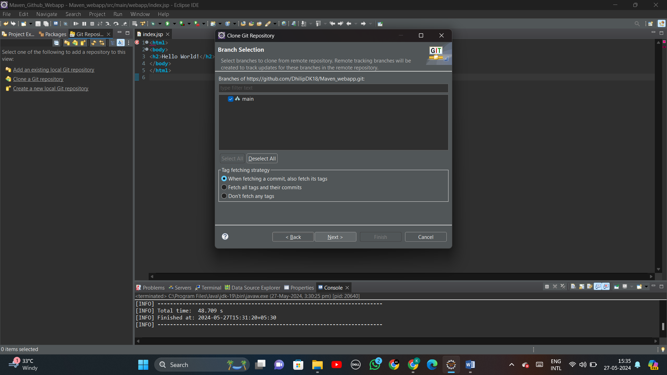

**Step 8:** Check your Directory and give ‘Finish’

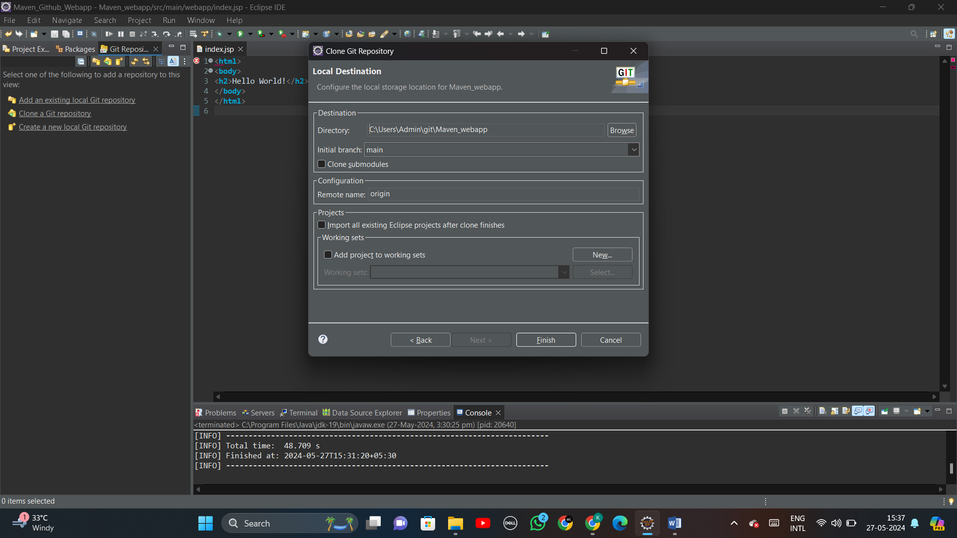

**Step 9:** Now your maven project will have a connection with the specified git repository

**Step 10:** Right click on the project -> Team -> Share project

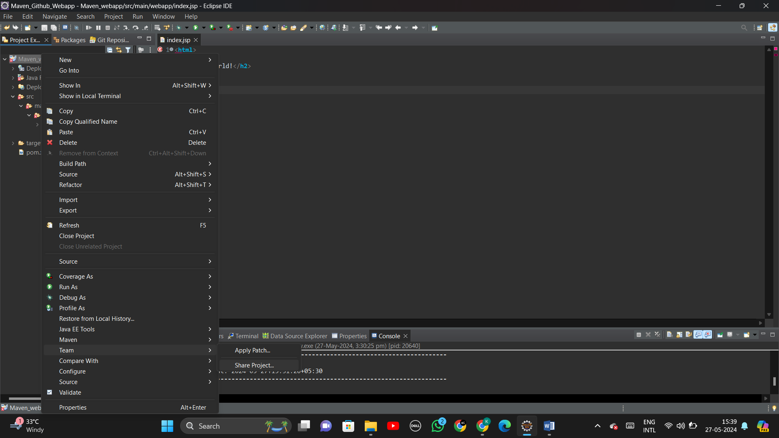

**Step 11:** In Share project, select the repository and check your working tree is properly selected.

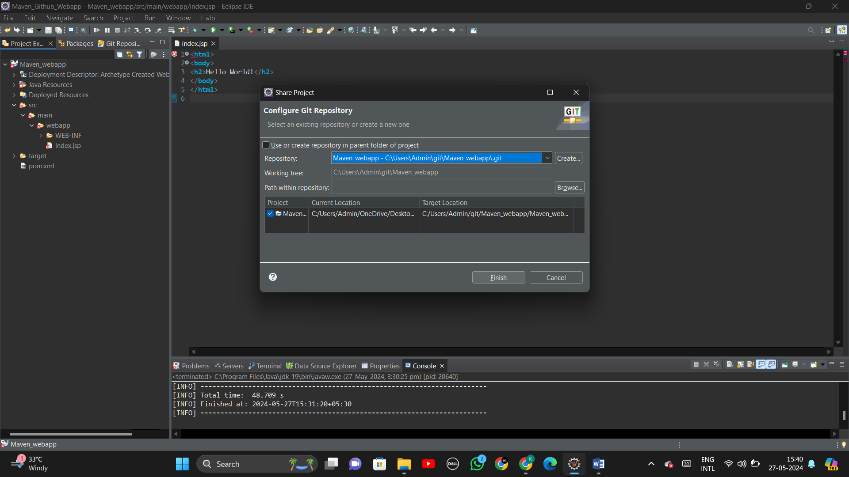

**Step 12:** Now, you can notice that the maven project is linked with the branch ‘main’ of your GitHub repository. (Example format: Project_name [Repo_name Branch_name]

**Step 13:** Follows the steps: Window -> Show view -> Others -> Git Staging.

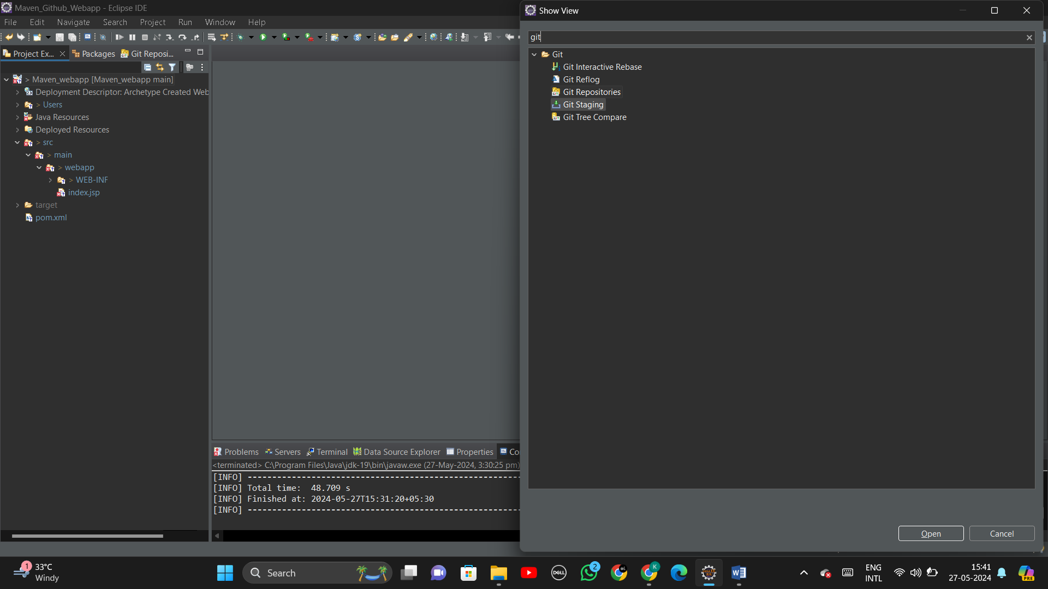

**Step 14:** Now, you can notice the maven project files are in ‘Unstaged changes’ section

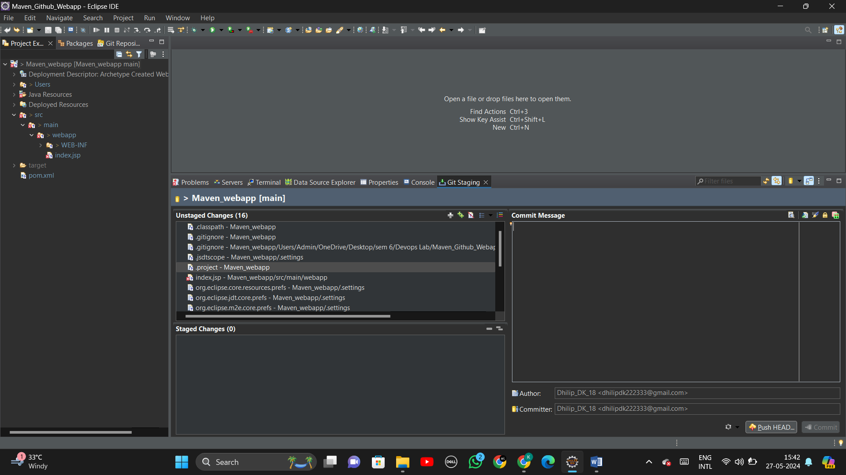

**Step 15:** Drag and drop all the maven project files from ‘Unstaged changes’ section to ‘Staged changes’ section.

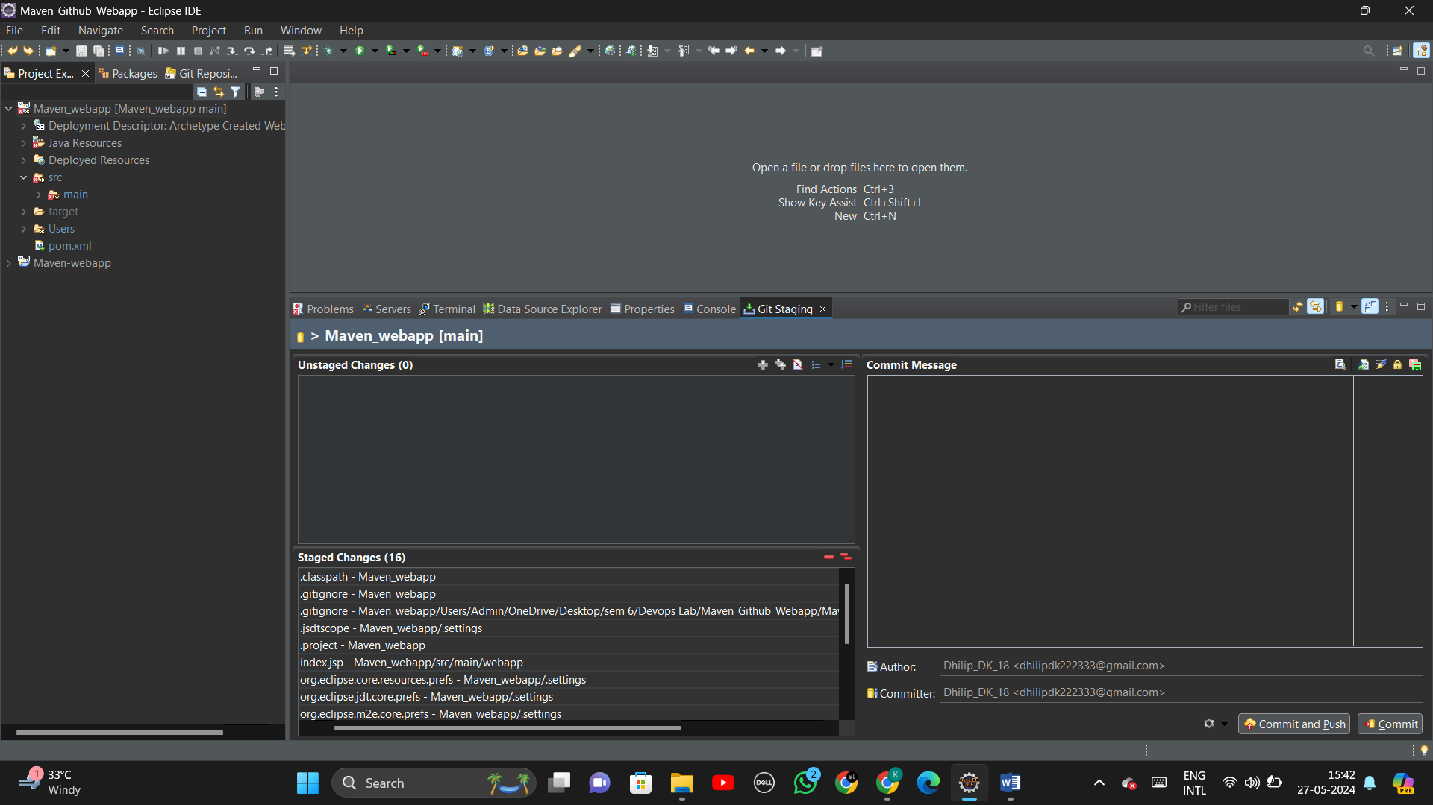

**Step 16:** Create a commit message and click ‘Commit and Push’.

**Step 17:** You will be asked to enter User and Password.

Enter the User: With your name of the GitHub account

Enter the password: As the token generated in GitHub on Step (3)

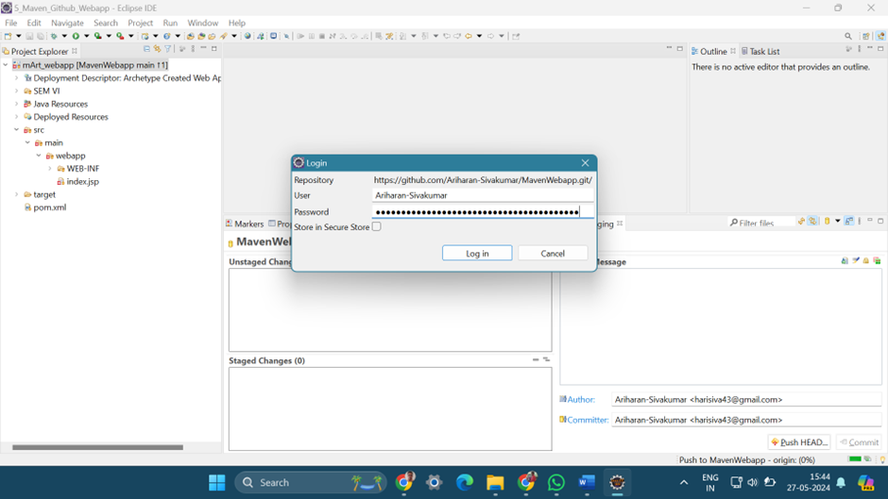

**Step 18:** Click ‘Push HEAD’ and then ‘Preview’

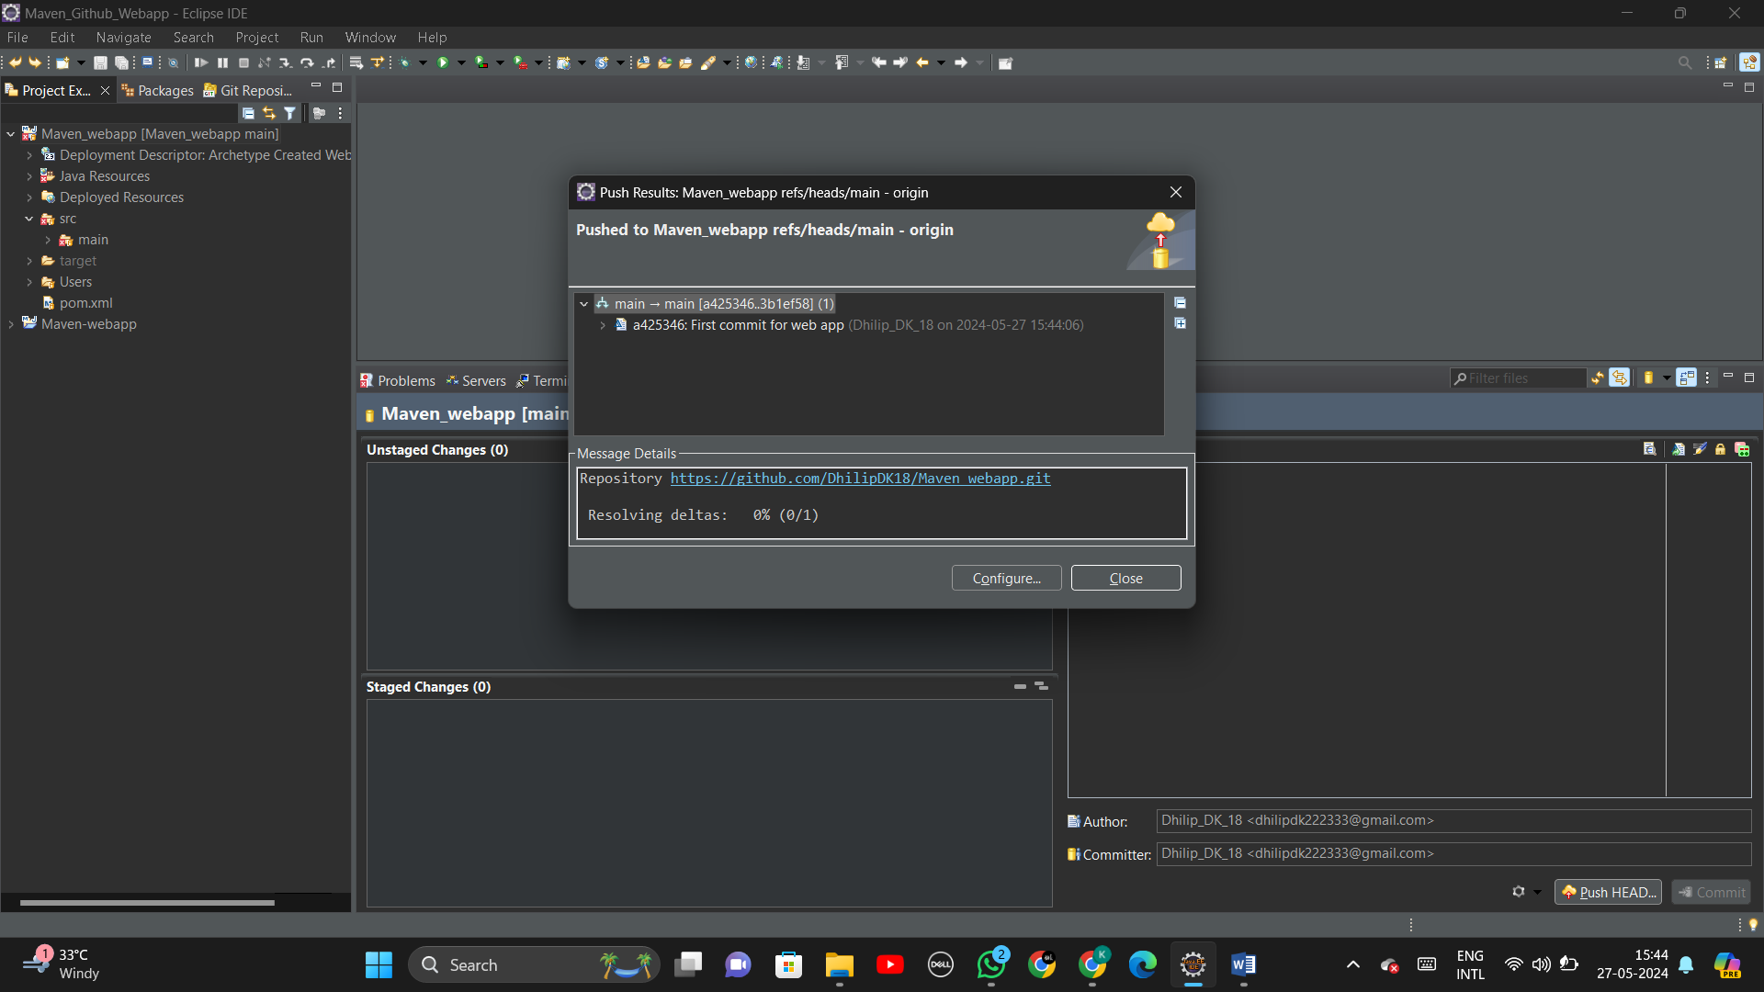

**Step 19:** Now, you can notice that the maven project files are pushed to the specified GitHub account

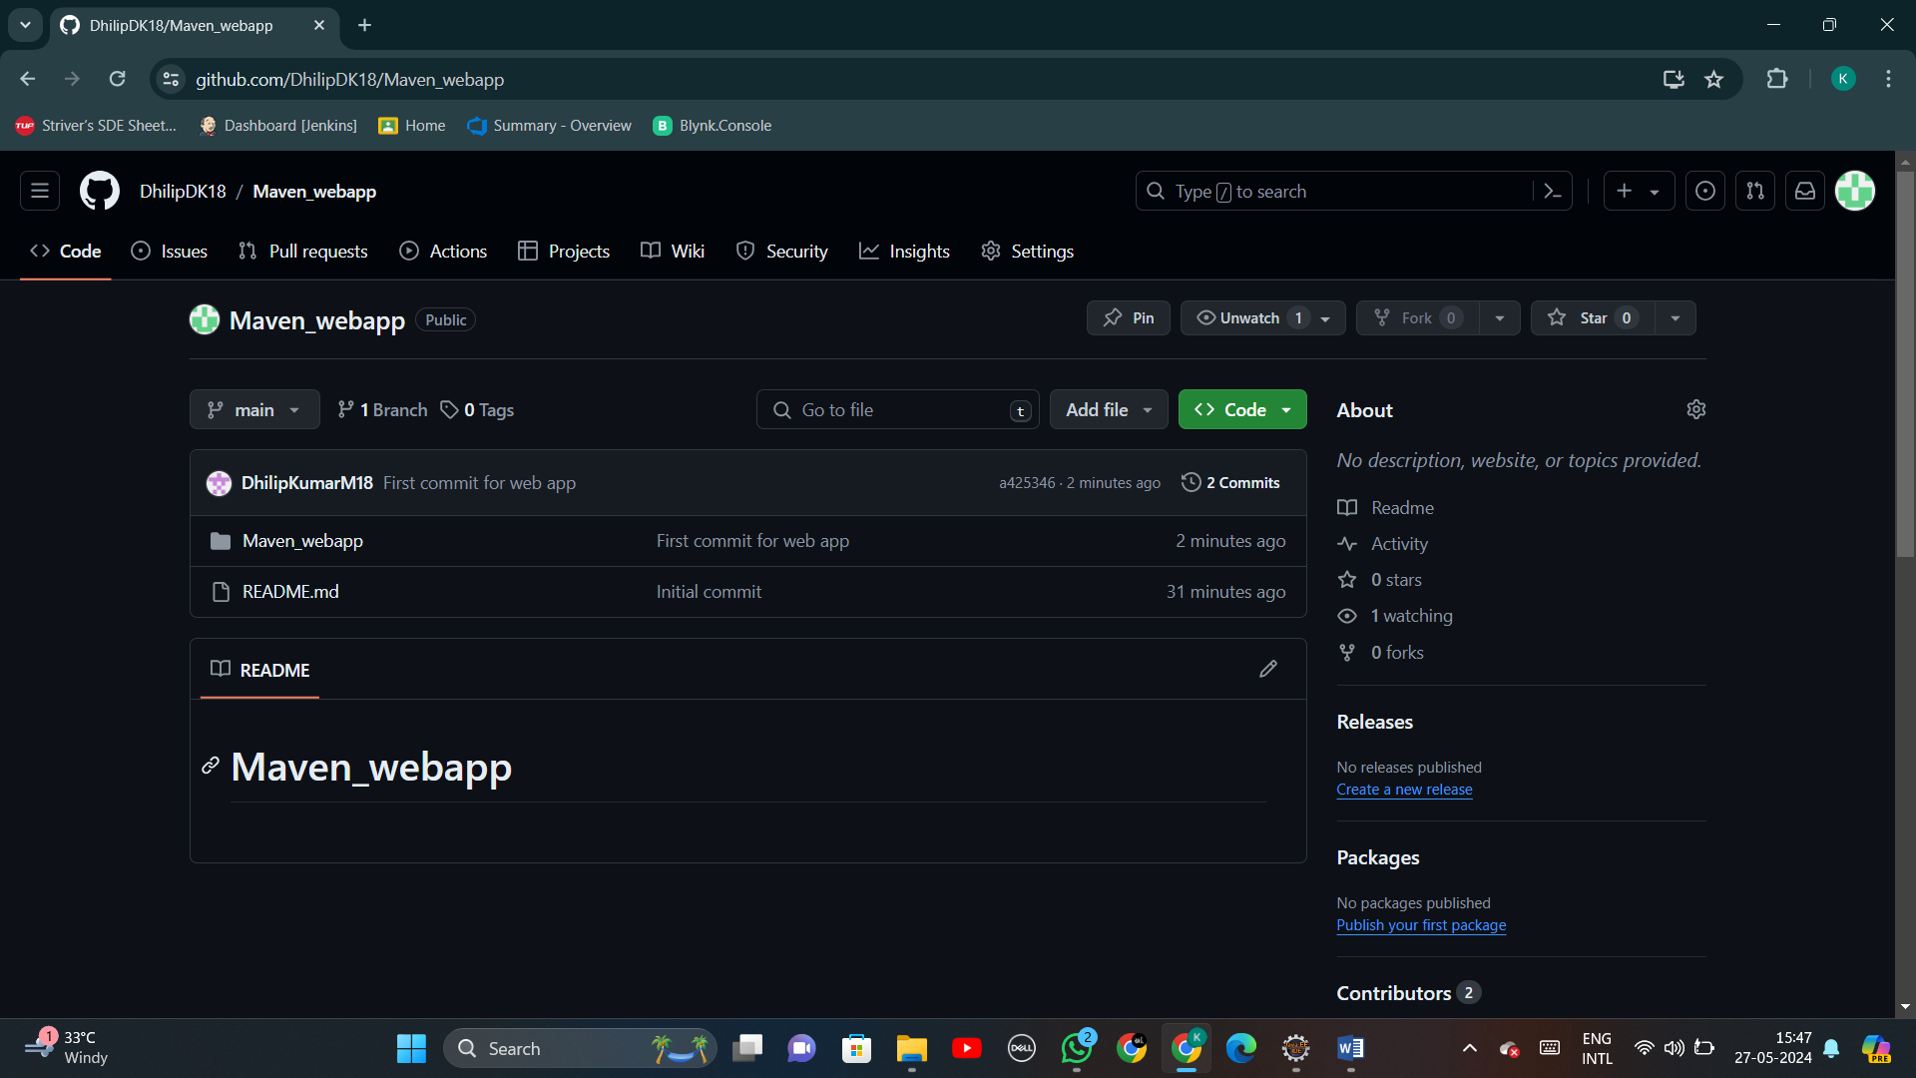

**----------------------( MAVEN WEB PROJECT - PHASE II ) ----------------------**

**Step 20:** Go to Jenkins by signing in and create a new pipeline by: New Item -> Give name -> Select the option ‘pipeline’ -> Create.

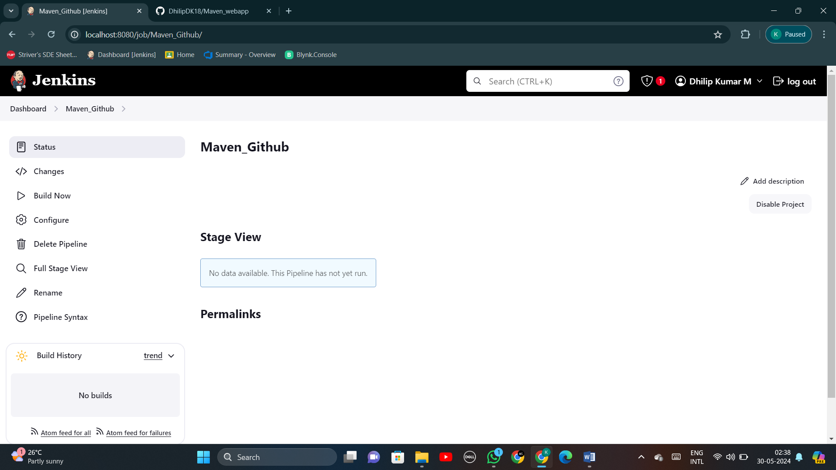

**Step 21:** Follow: Pipeline Syntax (At left) -> Select ‘git:Git”(on Sample Step).

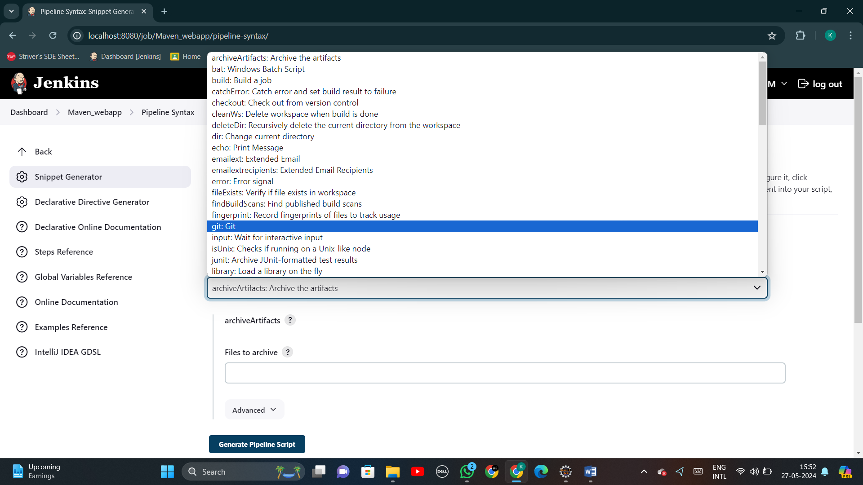

**Step 22:** Fill the Repository URL section with your GitHub repository URL -> Uncheck the “Include in poling?” and “Include in changing?” (above Generate Pipeline script)

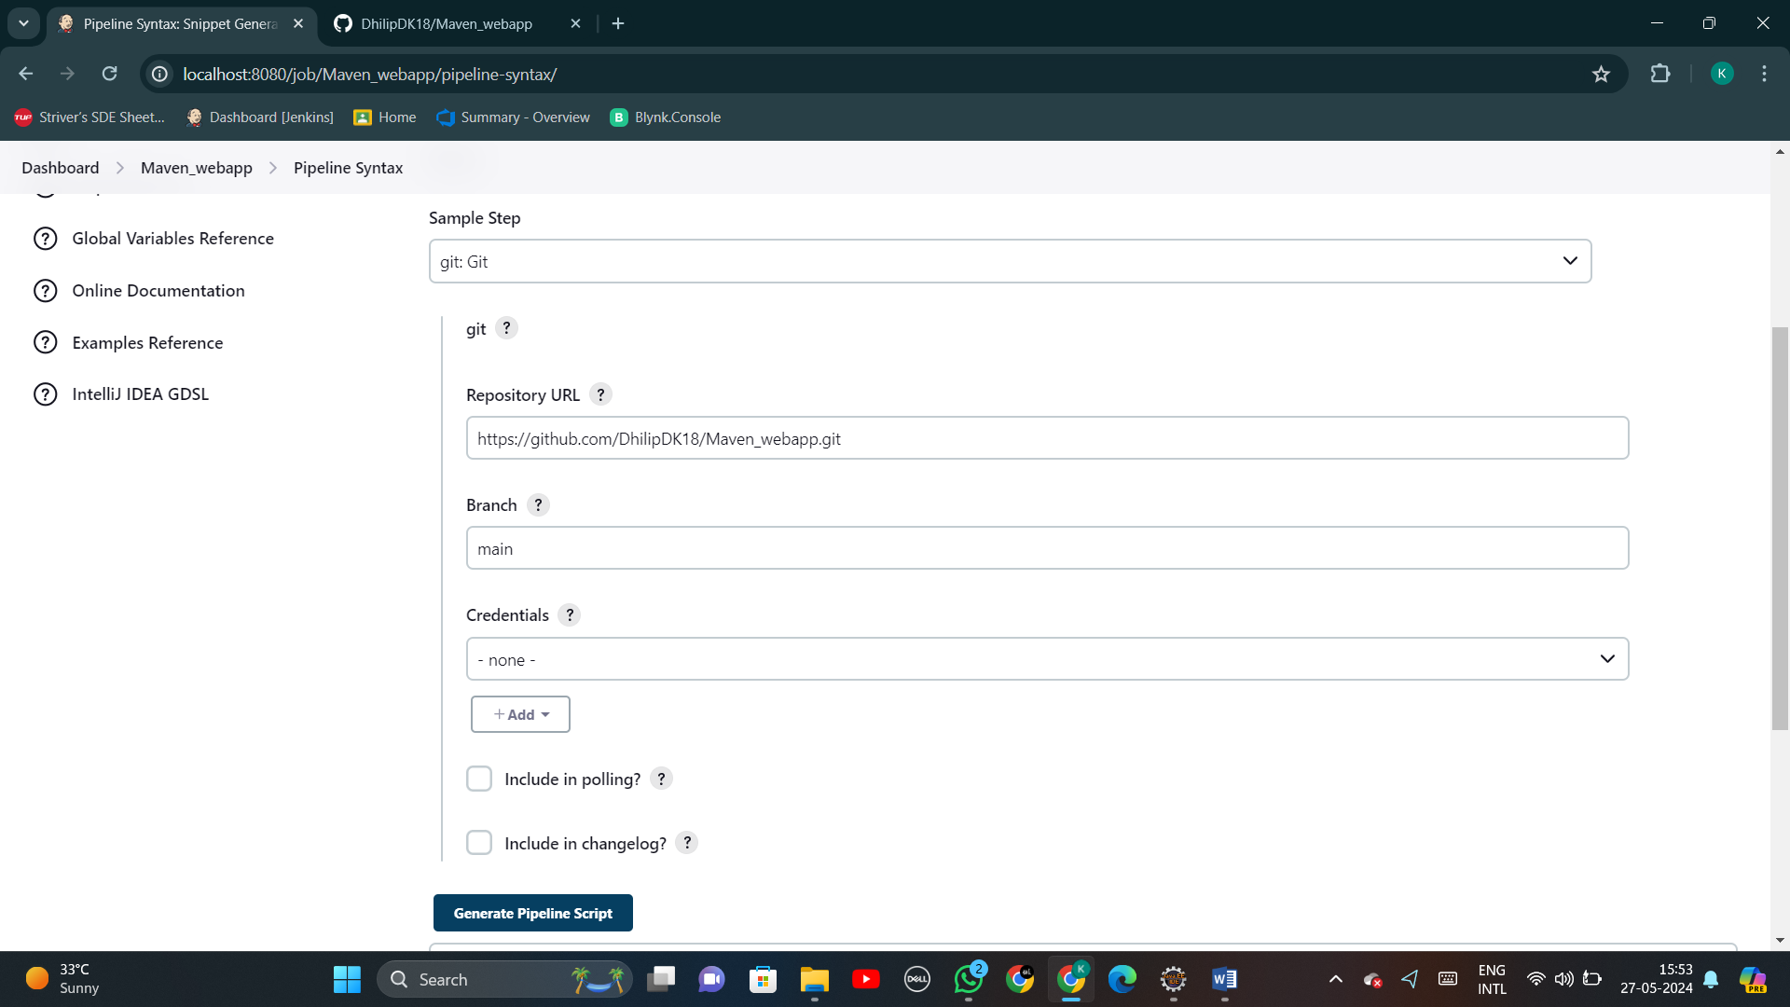

**Step 23:** Follow: Press Pipeline script -> Copy the link generated below the ‘Pipeline script’ button.

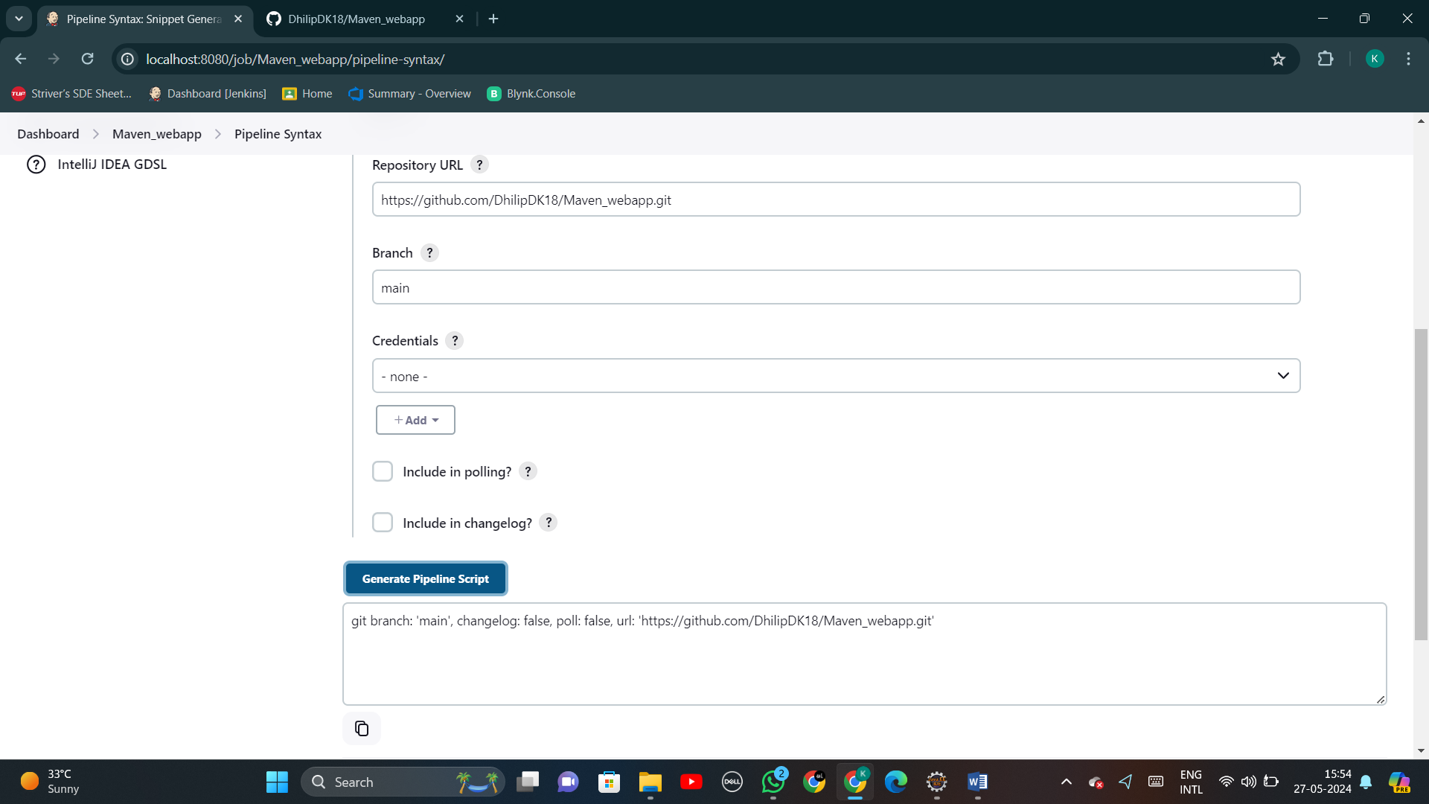

git branch: 'main', changelog: false, poll: false, url: 'https://github.com/Ariharan-Sivakumar/MavenWebapp.git'

**Step 24:** Now, move to ‘Maven_Github_Jenkins_Webapp’ (your new pipeline’s landing page) -> Configuration -> Pipeline -> Enter the below given script -> Save.

pipeline {

agent any

stages {

stage('Git Checkout') {

steps {

git branch: 'main', changelog: false, poll: false, url: 'https://github.com/DhilipDK18/Maven_webapp.git'

}

}

stage('Compile')

{

steps

{

bat "mvn -f Maven_webapp/pom.xml clean compile"

}

}

stage('Build')

{

steps

{

bat "mvn -f Maven_webapp/pom.xml install -DskipTest"

}

}

stage("Test Cases")

{

steps

{

bat "mvn -f Maven_webapp/pom.xml test"

}

}

stage("Deploy")

{

steps

{

bat "copy C:\\Users\\GOAT\\AppData\\Local\\Jenkins\\.jenkins\\workspace\\Maven_webapp\\Maven_webapp\\target\\Maven_webapp.war D:\\apache-tomcat-9.0.87-windows-x64\\apache-tomcat-9.0.87\\webapps"

}

}

}

}

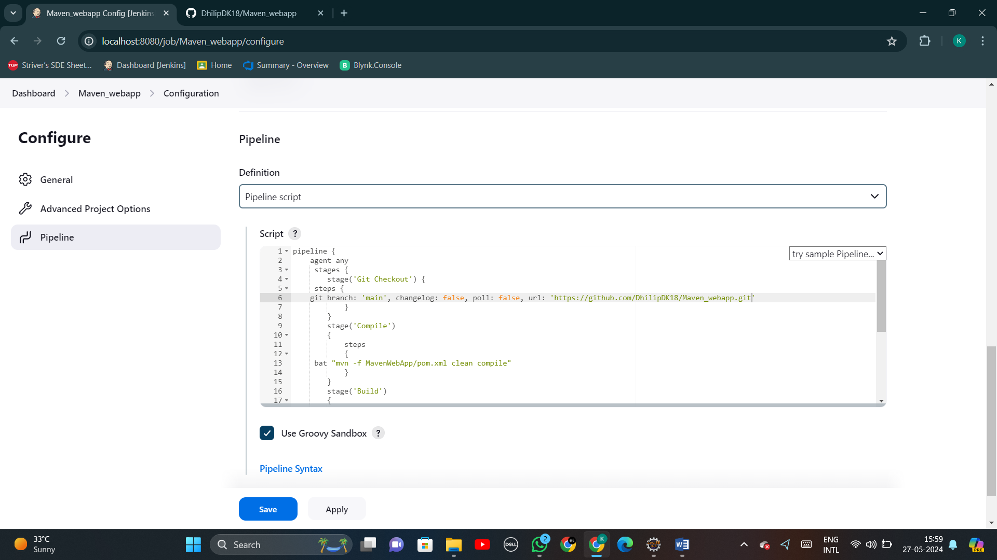

**Step 25:** Press “Build now” and wait until all the stages are completed.

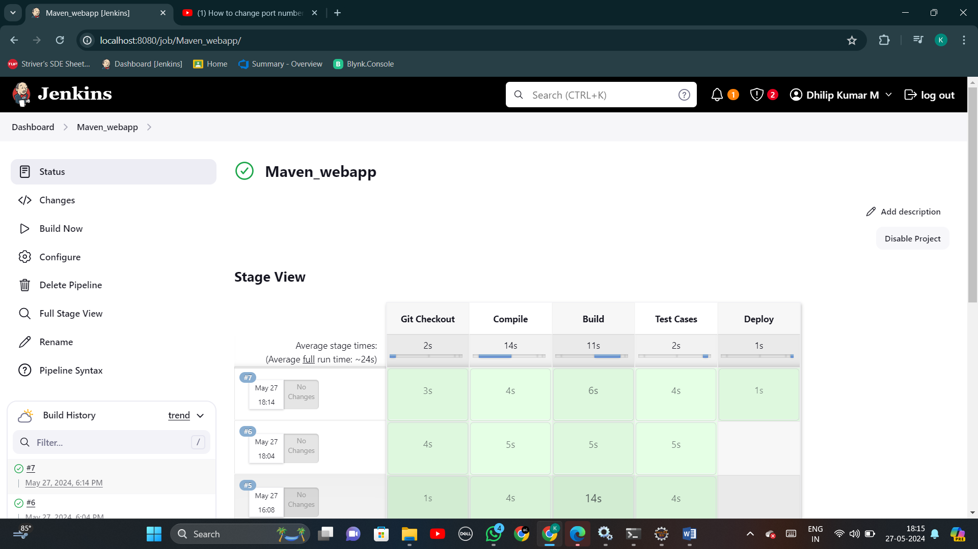

**Step 26:** Now, click the successfully built list in “Build history” list.

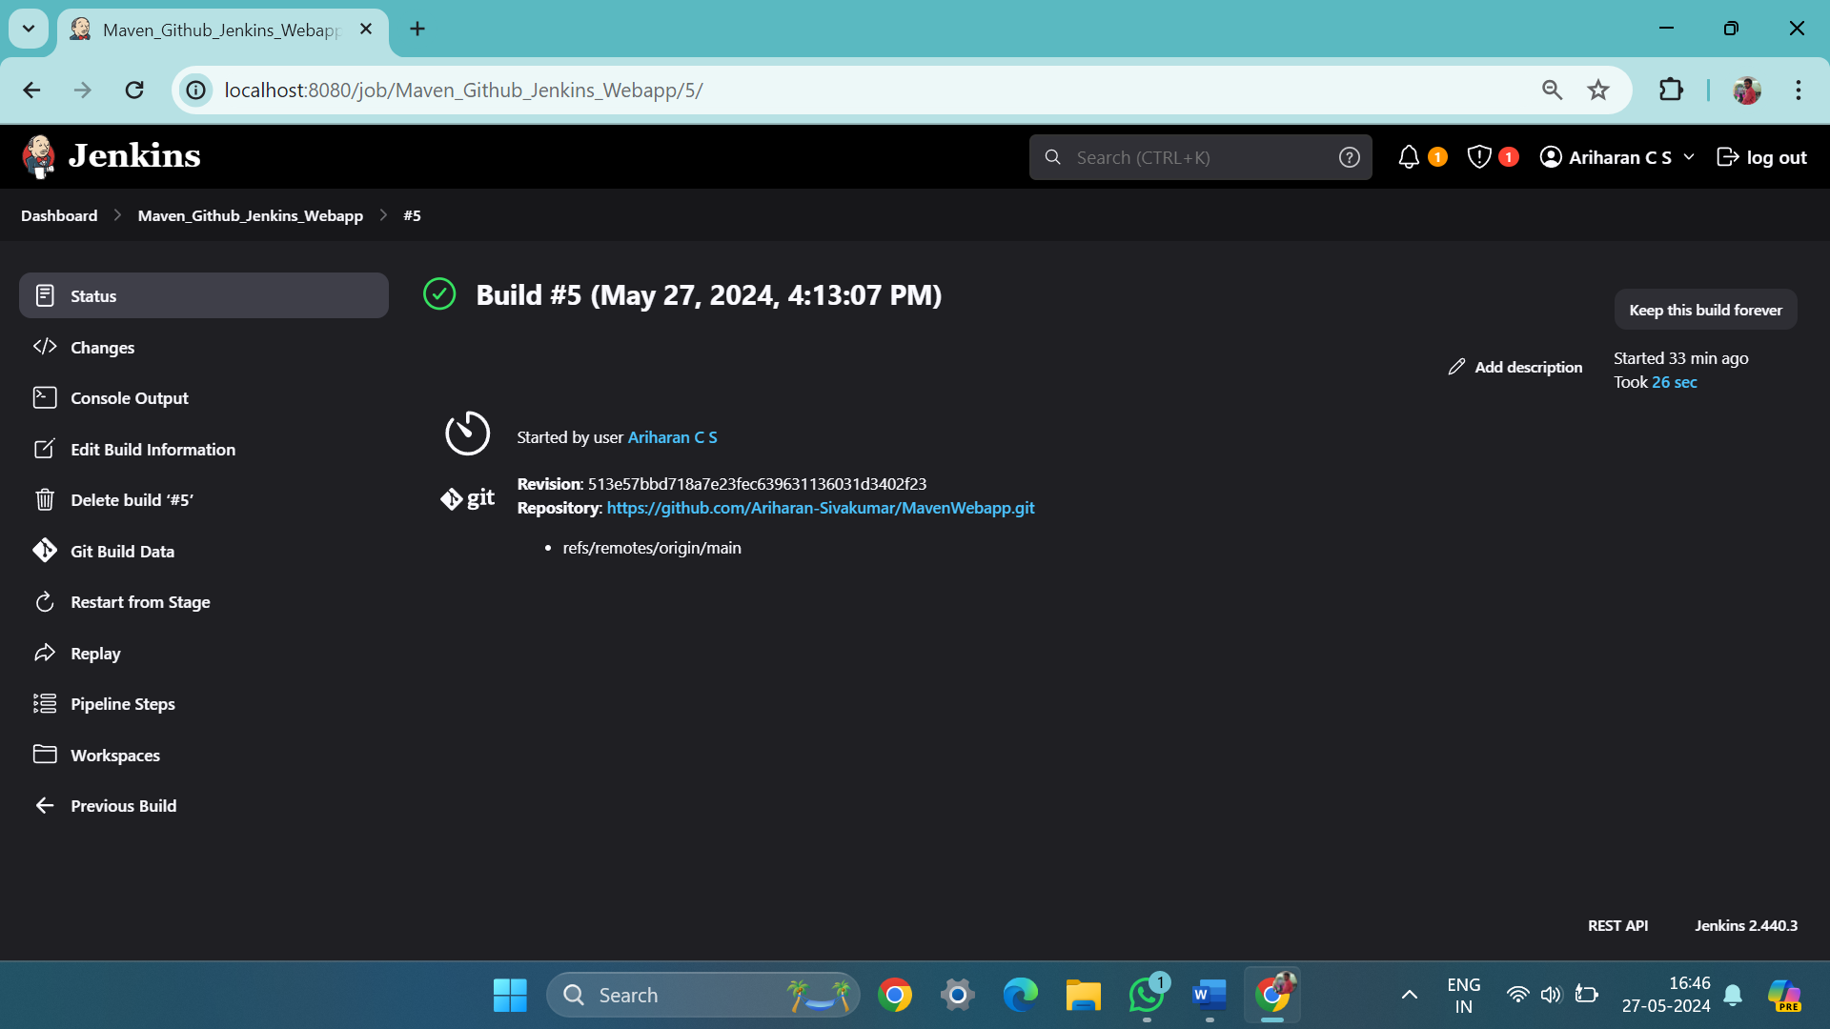

**Step 27:** Click the “Workspace” (at the left bottom) and copy the link present in your screen.

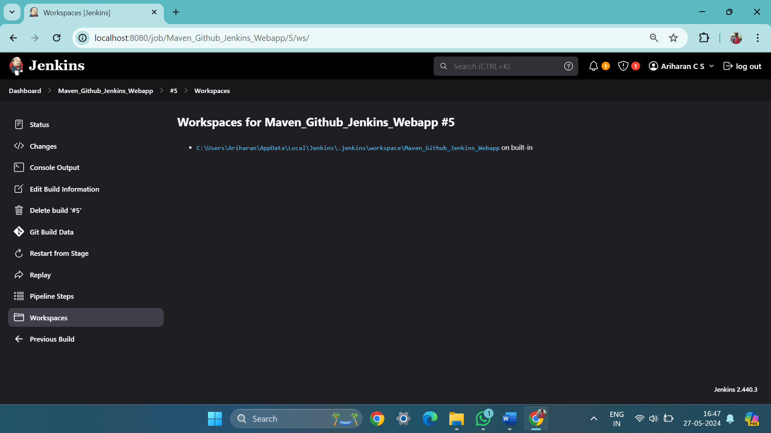

**Step 28:** Open a terminal -> Direct the current working directory to the link copied on the previous step -> (Follow) cd “your_repository_name” -> cd “target” -> Enter the command “dir” -> Check if the “.war” file is created on that folder.

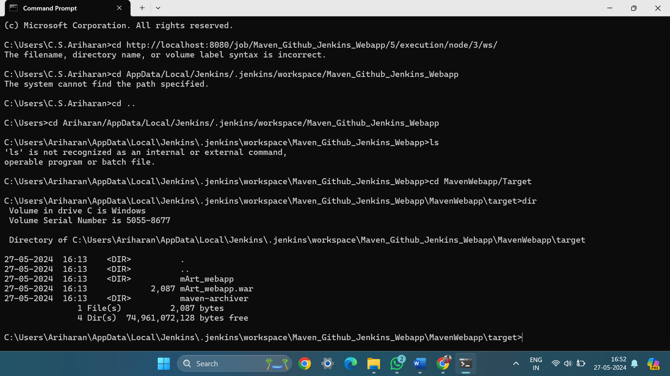

**Step 29:** Now, we are in the deploy stage. In this stage, the new created “.war” file has to be sent to the directory “tomcat/webapps” for running it on the “localhost:8080”.  
To perform this add the below code to existed code as another stage:  
stage(“Deploy”){

steps{bat “copy ‘.war file address’ ‘tomcat/webapps”}

}

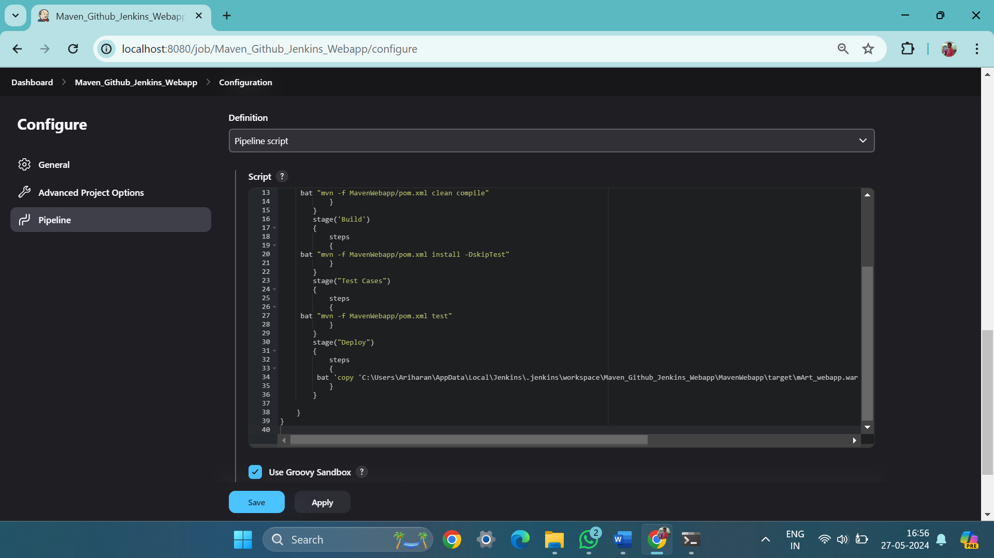

**Step 30:** Click ‘Save’ buttion -> ‘Build Now.



**Step 31:** Open a terminal -> Direct to “/tomcat/bin” directory -> Run “startup.bat”

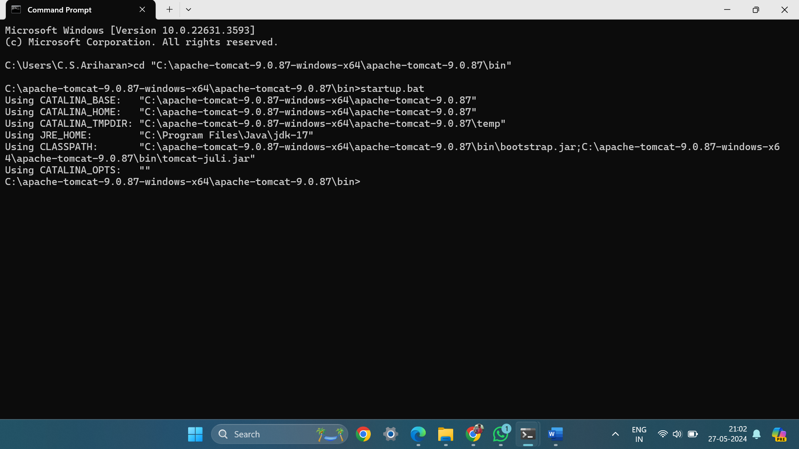

A new terminal will be opened as a server to track the operations done on that server (tomcat).

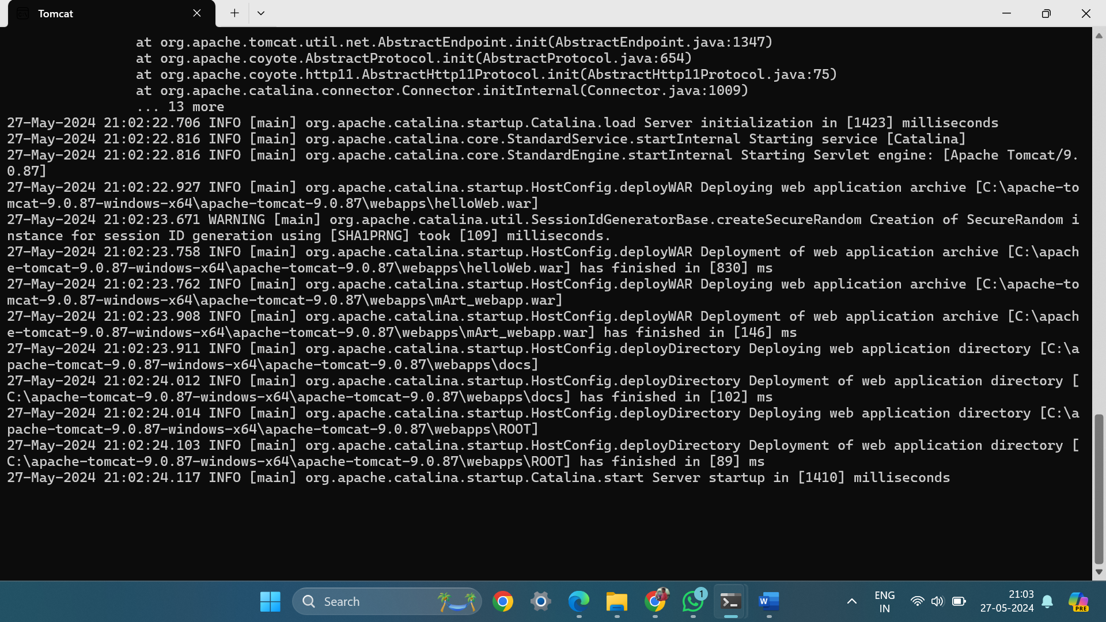

**Step 32:** Type “localhost:8080/MavenWebapp/” on any browser to view the webapp (output).

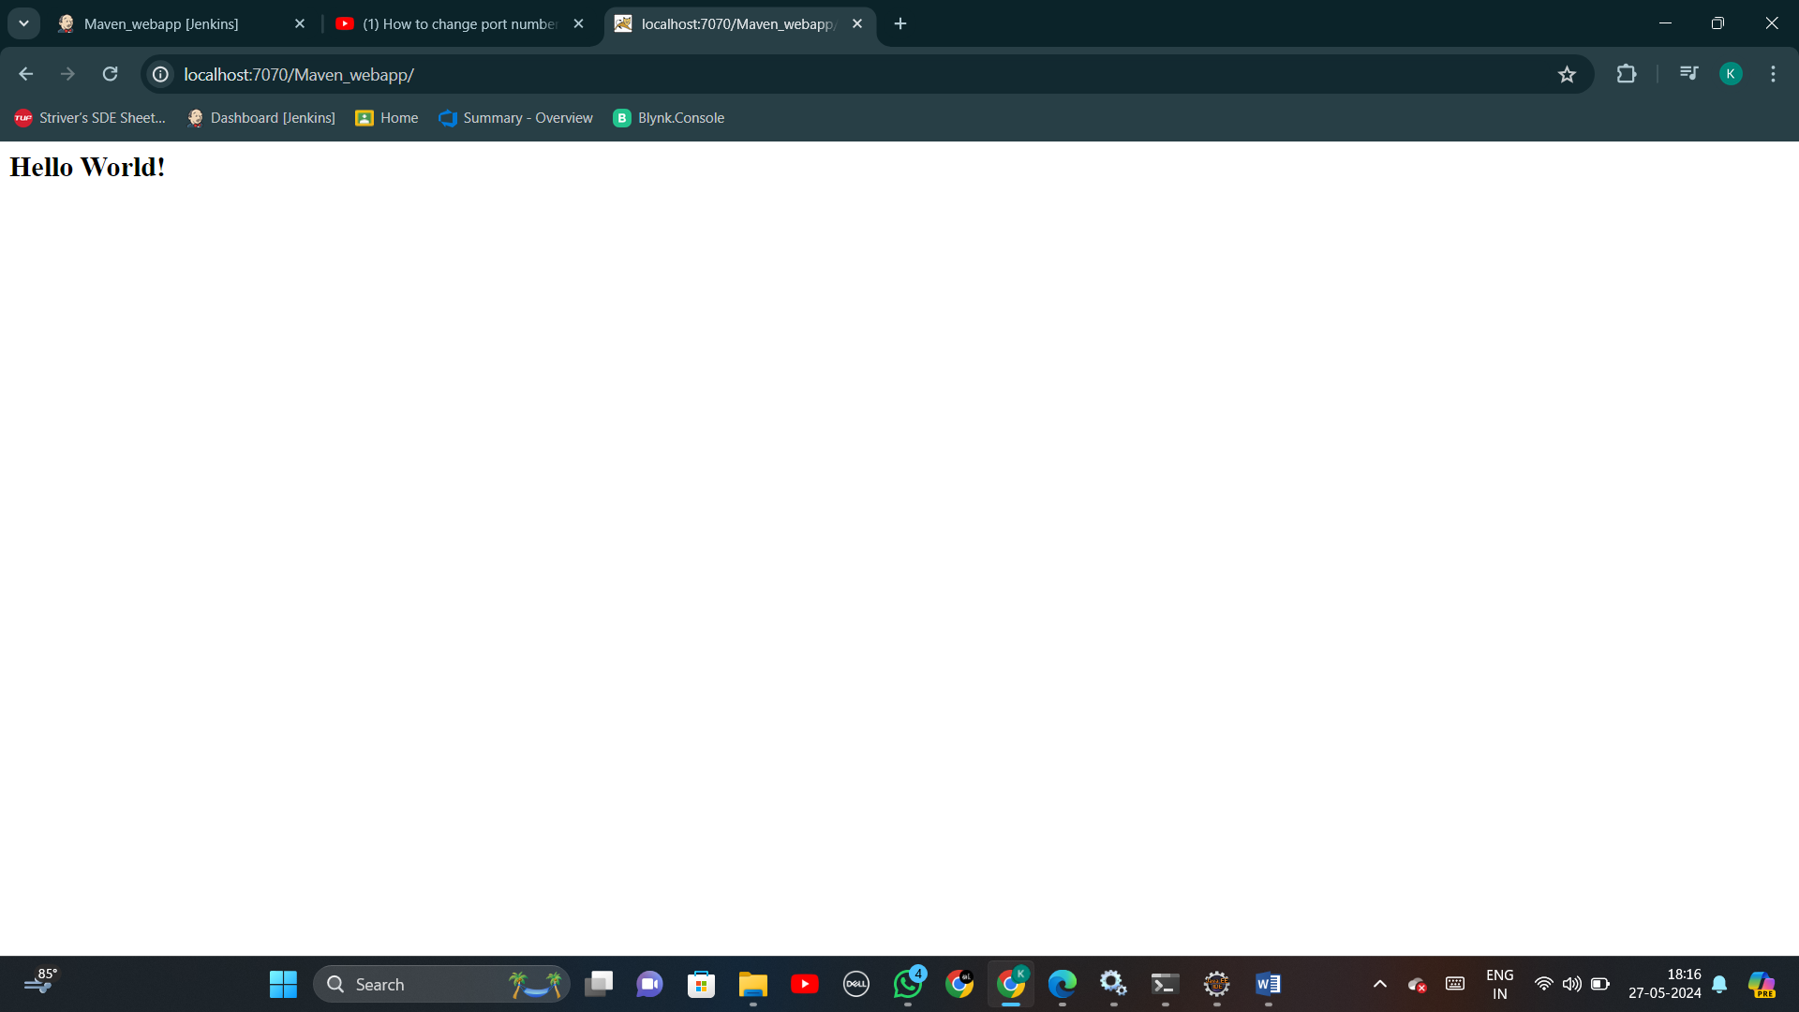

**Result:**

The above steps which show creation of maven projects, pushing it into Git repository and building it using Jenkins has been executed successfully.